Chapter 6
Supply, Demand, and Government Policies
MULTIPLE CHOICE
1. Price controls are
a. used to make markets more efficient.
b. usually enacted when policymakers believe that the market price of a good or service is unfair to buyers or sellers.
c. nearly always effective in eliminating inequities.
d. established by firms with monopoly power.
ANSWER: b. usually enacted when policymakers believe that the market price of a good or service is unfair to buyers or sellers.
TYPE: M DIFFICULTY: 2
2. Policymakers choose to enact price controls in a market because
a. they believe the market’s outcome to be unfair.
b. enacting price controls will directly increase tax revenues.
c. they are required by law to improve market conditions.
d. they believe that the market system is inefficient and their actions will improve efficiency.
ANSWER: a. they believe the market’s outcome to be unfair.
TYPE: M SECTION: 1 DIFFICULTY: 2
3. Policymakers are led to control prices because
a. they view the market’s outcome as inefficient.
b. they view the market’s outcome as unfair.
c. all politicians enjoy exercising their power.
d. they are required to do so under the Employment Act of 1946.
ANSWER: b. they view the market’s outcome as unfair.
TYPE: M SECTION: 1 DIFFICULTY: 2
4. Price controls
a. always produce an equitable outcome.
b. always produce an efficient outcome.
c. can generate inequities of their own.
d. produce revenue for the government.
ANSWER: c. can generate inequities of their own.
TYPE: M SECTION: 1 DIFFICULTY: 2
5. Which of the following is a reason policymakers impose taxes?
a. to attempt to make markets more efficient
b. to influence market outcomes
c. to raise revenue for public use
d. All of the above are correct.
e. Both b and c are correct.
ANSWER: e. Both b and c are correct.
TYPE: M SECTION: 1 DIFFICULTY: 2
6. A legal maximum price at which a good can be sold is a price
a. floor.
b. stabilization.
c. support.
d. ceiling.
ANSWER: d. ceiling.
TYPE: M SECTION: 1 DIFFICULTY: 1
7. A government-imposed maximum price at which a good can be sold is called a price
a. floor.
b. ceiling.
c. support.
d. equilibrium.
ANSWER: b. ceiling.
TYPE: M SECTION: 1 DIFFICULTY: 1
8. A price ceiling
a. is a legal maximum on the price at which a good can be sold.
b. is a legal minimum on the price at which a good can be sold.
c. occurs when the price in the market is temporarily above equilibrium.
d. will usually result in a market surplus.
ANSWER: a. is a legal maximum on the price at which a good can be sold.
TYPE: M SECTION: 1 DIFFICULTY: 1
9. A legal minimum price at which a good can be sold is a price
a. cut.
b. stabilization.
c. ceiling.
d. floor.
ANSWER: d. floor.
TYPE: M SECTION: 1 DIFFICULTY: 1
10. A price floor
a. is a legal minimum on the price at which a good can be sold.
b. is a legal maximum on the price at which a good can be sold.
c. will generally result in a market shortage.
d. will benefit the consumer, but hurt the supplier.
ANSWER: a. is a legal minimum on the price at which a good can be sold.
TYPE: M SECTION: 1 DIFFICULTY: 1
11. A price ceiling will only be binding if it is set
a. equal to equilibrium price.
b. above equilibrium price.
c. below equilibrium price.
d. A price ceiling is never binding in a free market system.
ANSWER: c. below equilibrium price.
TYPE: M SECTION: 1 DIFFICULTY: 2
12. A binding price ceiling causes
a. a shortage, which cannot be eliminated through market adjustment.
b. a surplus, which cannot be eliminated through market adjustment.
c. a shortage, which is temporary, since market adjustment will cause price to rise.
d. a surplus, which is temporary, since market adjustment will cause price to rise.
ANSWER: a. a shortage, which cannot be eliminated through market adjustment.
TYPE: M SECTION: 1 DIFFICULTY: 2
13. If a price ceiling is not binding,
a. the equilibrium price is above the ceiling.
b. the equilibrium price is below the ceiling.
c. it has no legal enforcement mechanism.
d. people must voluntarily agree to abide by it.
ANSWER: b. the equilibrium price is below the ceiling.
TYPE: M SECTION: 1 DIFFICULTY: 2
14. A price ceiling that is not binding will
a. cause a surplus in the market.
b. cause a shortage in the market.
c. cause the market to be less efficient.
d. have no effect on the market price.
ANSWER: d. have no effect on the market price.
TYPE: M SECTION: 1 DIFFICULTY: 2
15. Binding price ceilings in a market cause quantity demanded to be
a. greater than quantity supplied.
b. equal to quantity supplied.
c. less than quantity supplied.
d. Any of the above are possible.
ANSWER: a. greater than quantity supplied.
TYPE: M SECTION: 1 DIFFICULTY: 3
16. If a binding price ceiling is imposed in a market
a. there will be a surplus in the market.
b. the price will be legally forced toward equilibrium price.
c. there will be a shortage in the market.
d. market forces will guarantee that the price will be at equilibrium.
ANSWER: c. there will be a shortage in the market.
TYPE: M SECTION: 1 DIFFICULTY: 2

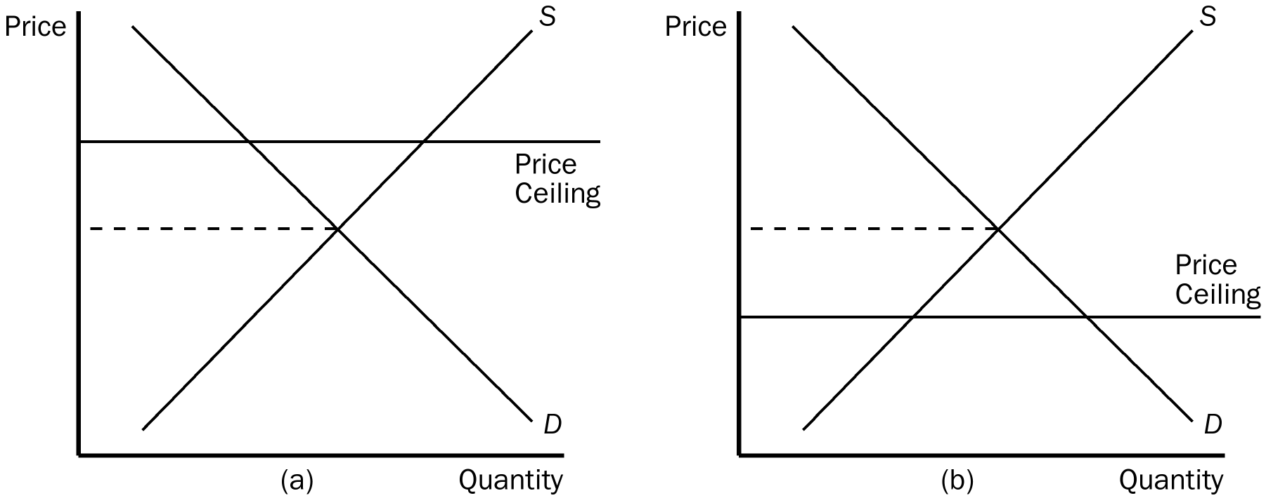

17. In the figure shown, a binding price ceiling is shown in
a. panel (a).
b. panel (b).
c. both panel (a) and panel (b).
d. neither panel (a) nor panel (b).
ANSWER: b. panel (b).
TYPE: M SECTION: 1 DIFFICULTY: 2
18. In which panel(s) in the figure shown would there be a shortage for CDs at the ceiling price?
a. panel (a)
b. panel (b)
c. panel (a) and panel (b)
d. neither panel (a) nor panel (b)
ANSWER: b. panel (b)
TYPE: M SECTION: 1 DIFFICULTY: 2
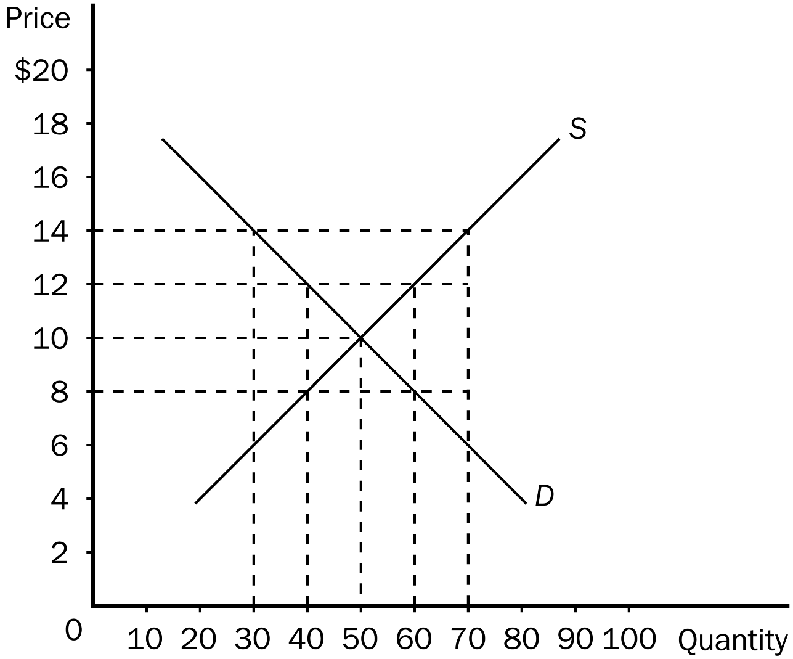
19. According to the graph shown, a binding price ceiling would exist at a price of
a. $14.00.
b. $12.00.
c. $10.00.
d. $8.00.
ANSWER: d. $8.00.
TYPE: M SECTION: 1 DIFFICULTY: 2
20. According to the graph shown, if the government imposes a binding price floor of $14.00 in this market, the result would be a
a. surplus of 20.
b. surplus of 40.
c. shortage of 20.
d. shortage of 40.
ANSWER: b. surplus of 40.
TYPE: M SECTION: 1 DIFFICULTY: 3
21. According to the graph shown, if the government imposes a binding price ceiling of $8.00 in this market, the result would be a
a. surplus of 20.
b. surplus of 40.
c. shortage of 20.
d. shortage of 40.
ANSWER: c. shortage of 20.
TYPE: M SECTION: 1 DIFFICULTY: 3
22. According to the graph, a binding price floor would exist at
a. a price of $10.00.
b. a price of $8.00.
c. any price above $10.00.
d. any price below $10.00.
ANSWER: c. any price above $10.00.
TYPE: M SECTION: 1 DIFFICULTY: 3
23. A price floor is binding if it is
a. higher than the equilibrium market price.
b. lower than the equilibrium market price.
c. equal to the equilibrium market price.
d. set by the government.
ANSWER: a. higher than the equilibrium market price.
TYPE: M SECTION: 1 DIFFICULTY: 2
24. With a binding price floor the market price will
a. be lower than the price floor.
b. be higher than the price floor.
c. equal the price floor.
d. It is impossible to compare the market price with the price floor.
ANSWER: a. be lower than the price floor.
TYPE: M SECTION: 1 DIFFICULTY: 2
25. A binding price floor in a market sets price
a. above equilibrium price and causes a shortage.
b. above equilibrium price and causes a surplus.
c. below equilibrium price and causes a surplus.
d. below equilibrium price and causes a shortage.
ANSWER: b. above equilibrium price and causes a surplus.
TYPE: M SECTION: 1 DIFFICULTY: 3
26. A price floor is not binding if
a. the price floor is higher than the equilibrium market price.
b. the price floor is lower than the equilibrium market price.
c. people are willing to buy less when the price floor is imposed as they did before.
d. the government sets it.
ANSWER: b. the price floor is lower than the equilibrium market price.
TYPE: M SECTION: 1 DIFFICULTY: 2
27. A binding price floor causes
a. excess demand.
b. a shortage.
c. a surplus.
d. equilibrium price to fall.
ANSWER: c. a surplus.
TYPE: M SECTION: 1 DIFFICULTY: 2
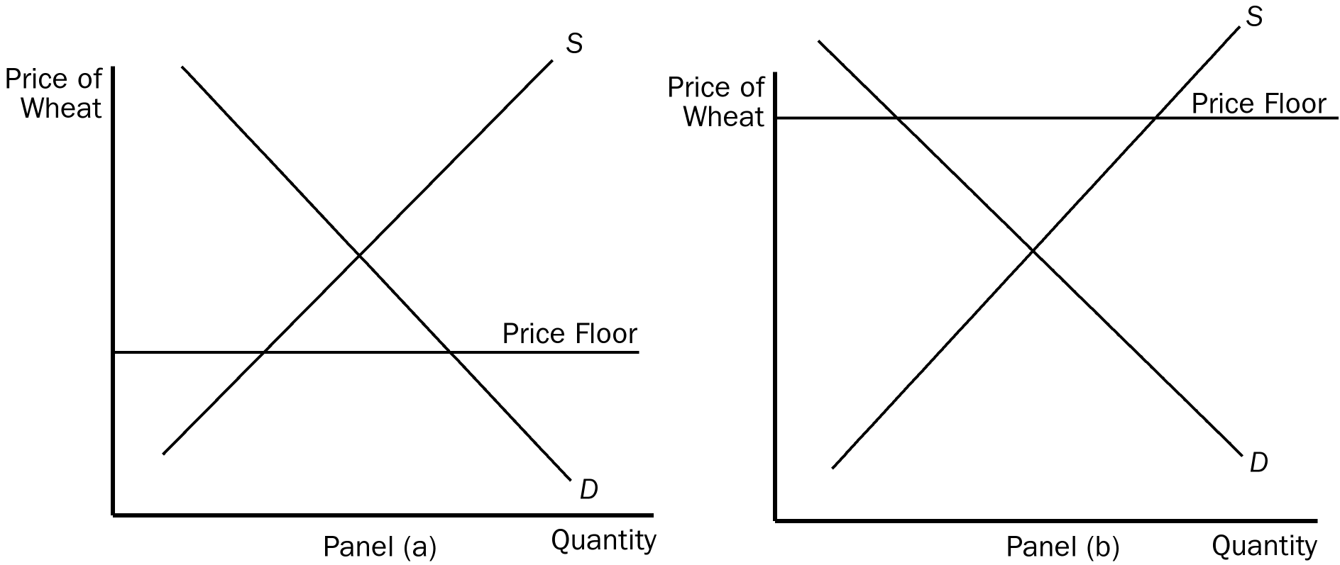
28. In the figure shown, which of the panels represents a binding price floor?
a. panel (a)
b. panel (b)
c. panel (a) and panel (b)
d. neither panel (a) nor panel (b)
ANSWER: b. panel (b)
TYPE: M SECTION: 1 DIFFICULTY: 2
29. In panel (b), at the actual price there will be
a. a shortage of wheat.
b. equilibrium in the market.
c. a surplus of wheat.
d. an excess demand for wheat.
ANSWER: c. a surplus of wheat.
TYPE: M SECTION: 1 DIFFICULTY: 2
30. If a price ceiling is a binding constraint on the market,
a. the equilibrium price must be below the price ceiling.
b. the equilibrium price must be above the price ceiling.
c. the forces of supply and demand must be in equilibrium.
d. it will have no effect on supply or demand.
ANSWER: b. the equilibrium price must be above the price ceiling.
TYPE: M SECTION: 1 DIFFICULTY: 2
31. If a price ceiling is a binding constraint, the
a. actual price will be below the price ceiling.
b. actual price will be above the price ceiling.
c. equilibrium price will equal the price ceiling.
d. actual price will equal the price ceiling.
ANSWER: d. actual price will equal the price ceiling.
TYPE: M SECTION: 1 DIFFICULTY: 3
32. When binding price ceilings are imposed in a market
a. price no longer serves as a rationing device.
b. the market will be cleared of any shortages or surpluses that existed previously.
c. buyers and sellers both benefit equally.
d. the government is attempting to improve market efficiency.
ANSWER: a. price no longer serves as a rationing device.
TYPE: M SECTION: 1 DIFFICULTY: 3
33. When binding price ceilings are imposed to benefit buyers
a. every buyer in the market benefits because of lower prices.
b. some buyers will not be able to buy any of the product.
c. sellers in the market will equally benefit from a price ceiling.
d. the quantity sellers want to sell will equal the quantity buyers want to buy.
ANSWER: b. some buyers will not be able to buy any of the product.
TYPE: M SECTION: 1 DIFFICULTY: 2
34. A binding price ceiling is imposed on the market for peaches. At the ceiling price, the quantity demanded of peaches will be
a. greater than the quantity supplied.
b. equal to the quantity supplied.
c. smaller than the quantity supplied.
d. artificially restricted by the price ceiling.
ANSWER: a. greater than the quantity supplied.
TYPE: M SECTION: 1 DIFFICULTY: 3
35. A binding price ceiling in the computer market will cause
a. a surplus of computers.
b. a shortage of computers.
c. quantity demanded of computers to be equal to quantity supplied.
d. an increase in the demand for computers.
ANSWER: b. a shortage of computers.
TYPE: M SECTION: 1 DIFFICULTY: 2
36. A binding price ceiling will make it necessary to
a. supply more of the product.
b. develop a way of rationing the product, because there will be a shortage.
c. develop a better marketing plan, because there will be a surplus.
d. increase demand for the product.
ANSWER: b. develop a way of rationing the product, because there will be a shortage.
TYPE: M SECTION: 1 DIFFICULTY: 3
37. Binding price ceilings result in each of the following EXCEPT
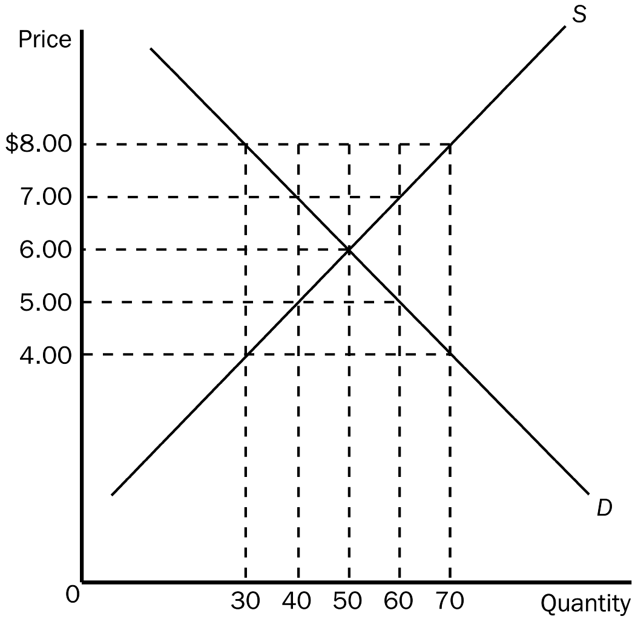
a. market inefficiency.
b. shortages.
c. seller bias.
d. surpluses.
ANSWER: d. surpluses.
TYPE: M SECTION: 1 DIFFICULTY: 2
38. According to the graph shown, if the government imposes a binding price ceiling in this market at a price of $5.00, the result would be a
a. shortage of 20 units.
b. shortage of 10 units.
c. surplus of 20 units.
d. surplus of 10 units.
ANSWER: a. shortage of 20 units.
TYPE: M SECTION: 1 DIFFICULTY: 2
39. According to the graph shown, a binding price ceiling would exist at a price of
a. $8.00.
b. $6.00.
c. $5.00.
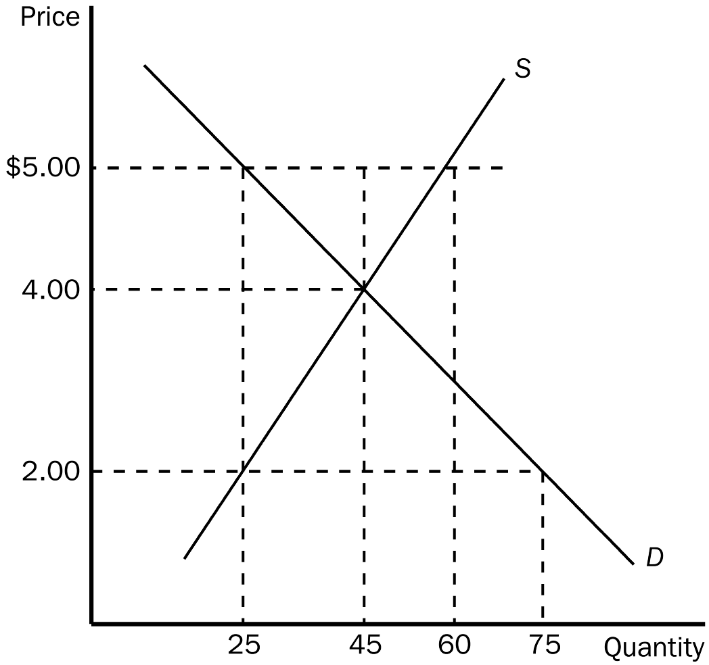
d. It could exist at any price above $6.00.
ANSWER: c. $5.00.
TYPE: M SECTION: 1 DIFFICULTY: 2
40. According to the graph shown, if the government imposes a binding price floor of $5.00 in this market, the result would be a
a. surplus of 15.
b. surplus of 35.
c. surplus of 20.
d. shortage of 20.
ANSWER: b. surplus of 35.
TYPE: M SECTION: 1 DIFFICULTY: 2
41. According to the graph shown, a binding price floor would exist at a price of
a. $5.00.
b. $4.00.
c. $2.00.
d. It could exist at any price below $4.00.
ANSWER: a. $5.00.
TYPE: M SECTION: 1 DIFFICULTY: 2
42. Rationing by long lines is
a. inefficient, because it wastes buyers’ time.
b. efficient, because those who are willing to wait the longest get the goods.
c. the only way scarce goods can be rationed.
d. only necessary if price ceilings are not binding.
ANSWER: a. inefficient, because it wastes buyers’ time.
TYPE: M SECTION: 1 DIFFICULTY: 1
43. Price ceilings and price floors
a. are desirable because they make markets more efficient as well as equitable.
b. cause surpluses and shortages to persist since price cannot adjust to the market equilibrium price.
c. can be enacted to restore a market to equilibrium.
d. are imposed because they can make the poor in the economy better off without causing adverse effects.
ANSWER: b. cause surpluses and shortages to persist since price cannot adjust to the market equilibrium price.
TYPE: M SECTION: 1 DIFFICULTY: 2
44. In the 1970s, long lines at gas stations in the United States were primarily a result of the fact that
a. OPEC raised the price of crude oil in world markets.
b. U.S. gasoline producers raised the price of gasoline.
c. the U.S. government imposed a price ceiling on gasoline.
d. Americans typically commute long distances.
ANSWER: c. the U.S. government had imposed a price ceiling on gasoline.
TYPE: M SECTION: 1 DIFFICULTY: 2
45. Other than OPEC, the shortage of gasoline in the U.S. in the 1970s could also be blamed on
a. a sharp increase in the demand for gasoline needed for the Vietnam war.
b. government regulations in the form of a price ceiling.
c. an indifference among U.S. consumers toward conservation.
d. the lack of alternative sources of crude oil.
ANSWER: b. government regulations in the form of a price ceiling.
TYPE: M SECTION: 1 DIFFICULTY: 2
46. When OPEC raised the price of crude oil in the 1970s, it caused the
a. demand for gasoline to increase.
b. demand for gasoline to decrease.
c. supply of gasoline to increase.
d. supply of gasoline to decrease.
ANSWER: d. supply of gasoline to decrease.
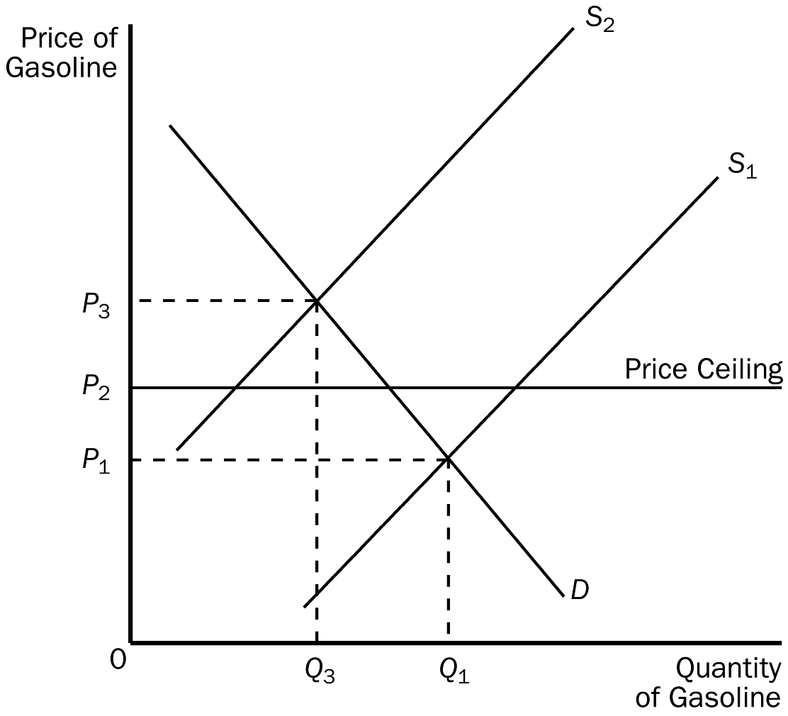
TYPE: M SECTION: 1 DIFFICULTY: 2
47. According to the graph shown, with a price ceiling present in this market, when the supply curve for gasoline shifts from S1 to S2
a. the price will increase to P3.
b. a surplus will occur at the new market price of P2.
c. the market price will stay at P1 due to the price ceiling.
d. a shortage will occur at the price ceiling of P2.
ANSWER: d. a shortage will occur at the price ceiling of P2.
TYPE: M SECTION: 1 DIFFICULTY: 3
48. Without the price ceiling in this market for gasoline, when the supply curve shifts from S1 to S2 the price will
a. increase to P3, but a shortage will still exist.
b. increase to P3 and the market will clear.
c. remain at P1 and a shortage will still exist.
d. eventually move to P2 without government assistance.
ANSWER: b. increase to P3 and the market will clear.
TYPE: M SECTION: 1 DIFFICULTY: 3
49. Water shortages caused by droughts can be most efficiently lessened by
a. allowing price to equate the quantity demanded of water with the quantity supplied of water.
b. restricting water usage of consumers.
c. arresting anyone who wastes water.
d. imposing tight price controls on water.
ANSWER: a. allowing price to equate the quantity demanded of water with the quantity supplied of water.
TYPE: M SECTION: 1 DIFFICULTY:2
50. Water shortages can be most efficiently eliminated even in times of drought if
a. the market is allowed to adjust freely.
b. water can be moved from where it is plentiful to where it is needed most.
c. government intervention occurs to regulate water usage.
d. the price is low enough for everyone to have all the water they want.
ANSWER: a. the market is allowed to adjust freely.
TYPE: M SECTION: 1 DIFFICULTY: 2
51. California’s drought-emergency water bank
a. caused a severe water shortage in 1991.
b. causes water to be fixed in supply.
c. allows farmers to lease water during dry spells.
d. caused the price of water during the last drought to fall.
ANSWER: c. allows farmers to lease water during dry spells.
TYPE: M SECTION: 1 DIFFICULTY: 2
52. Rent control is
a. a common example of a social problem solved by government regulation.
b. a common example of a price ceiling.
c. the most effective way to provide affordable housing.
d. the most efficient way to allocate housing.
ANSWER: b. a common example of a price ceiling.
TYPE: M SECTION: 1 DIFFICULTY: 2
53. Over time, housing shortages caused by rent control
a. increase, because the demand and supply curves for housing are more elastic in the long run.
b. increase, because the demand and supply curves for housing are more inelastic in the long run.
c. decrease, because the demand and supply curves for housing are more inelastic in the long run.
d. change very little since price is not allowed to adjust.
ANSWER: a. increase, because the demand and supply curves for housing are more elastic in the long run.
TYPE: M SECTION: 1 DIFFICULTY: 2
54. Economists generally hold that rent control is
a. an efficient and equitable way to help the poor.
b. not efficient, but the best way to solve a serious social problem.
c. a highly inefficient way to help the poor raise their standard of living.
d. an efficient way to allocate housing, but not a good way to help the poor.
ANSWER: c. a highly inefficient way to help the poor raise their standard of living.
TYPE: M SECTION: 1 DIFFICULTY: 2
55. In the housing market, rent controls cause quantity supplied to
a. fall and quantity demanded to fall.
b. fall and quantity demanded to rise.
c. rise and quantity demanded to fall.
d. rise and quantity demanded to rise.
ANSWER: b. fall and quantity demanded to rise.
TYPE: M SECTION: 1 DIFFICULTY: 3

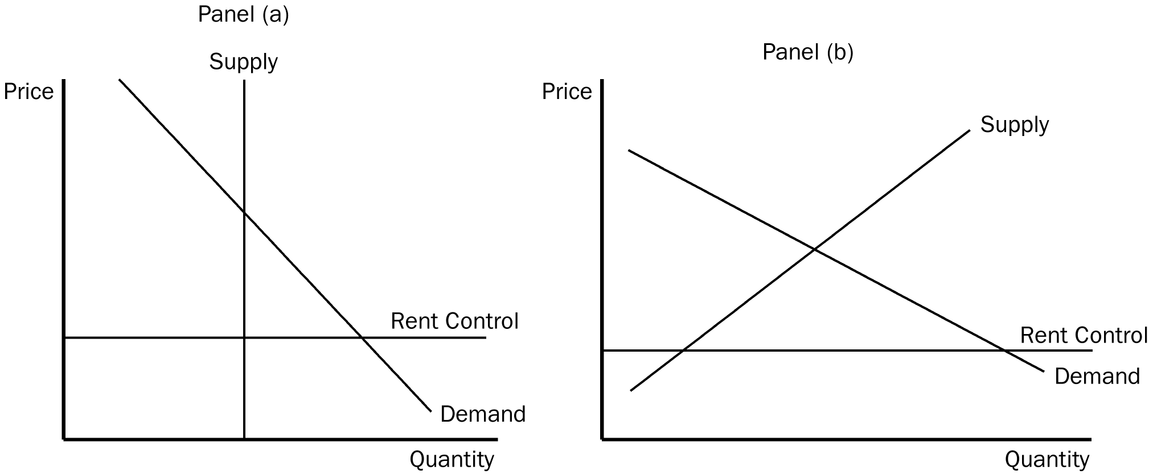

56. In the figure shown, which panel(s) best represent(s) a binding rent control in the short run?
a. panel (a)
b. panel (b)
c. neither panel
d. both panels
ANSWER: a. panel (a)
TYPE: M SECTION: 1 DIFFICULTY: 2
57. In the figure shown, which panel(s) best represent(s) a binding rent control in the long run?
a. panel (a)
b. panel (b)
c. neither panel
d. both panels
ANSWER: b. panel (b)
TYPE: M SECTION: 1 DIFFICULTY: 2
58. Which of the following is NOT a mechanism of rationing used by landlords in cities with rent control?
a. waiting lists
b. race
c. price
d. bribes
ANSWER: c. price
TYPE: M SECTION: 1 DIFFICULTY: 1
59. Under rent control, bribery is a mechanism to
a. bring the total price of an apartment (including the bribe) closer to the equilibrium price.
b. allocate housing to the poorest individuals in the market.
c. force the total price of an apartment (including the bribe) to be less than the market price.
d. allocate housing to the most deserving tenants.
ANSWER: a. bring the total price of an apartment (including the bribe) closer to the equilibrium price.
TYPE: M SECTION: 1 DIFFICULTY: 2
60. Under rent control, tenants can expect
a. lower rent and higher quality housing.
b. lower rent and lower quality housing.
c. higher rent and higher quality housing.
d. higher rent and lower quality housing.
ANSWER: b. lower rent and lower quality housing.
TYPE: M SECTION: 1 DIFFICULTY: 2
61. Under rent control, landlords cease to be responsive to tenants’ concerns about the quality of the housing because
a. with shortages and waiting lists, they have no incentive to maintain and improve their property.
b. they know they can never please their tenants.
c. the law no longer requires them to maintain their buildings.
d. it becomes the government’s responsibility.
ANSWER: a. with shortages and waiting lists, they have no incentive to maintain and improve their property.
TYPE: M SECTION: 1 DIFFICULTY: 2
62. Which of the following is NOT a result of government imposed rent controls?
a. fewer new apartments offered for rent
b. less maintenance provided by landlords
c. bribery
d. higher quality housing
ANSWER: d. higher quality housing
TYPE: M SECTION: 1 DIFFICULTY: 2
63. Which of the following statements about rent control in New York City is accurate?
a. Rent control has proven successful in providing low-cost housing for poor people.
b. Rent control has produced an increase in available rental units.
c. Many well-to-do people live in rent-controlled apartments.
d. All of the above are accurate statements.
ANSWER: c. Many well-to-do people live in rent-controlled apartments.
TYPE: M SECTION: 1 DIFFICULTY: 2
64. The minimum wage is an example of
a. a price ceiling.
b. a price floor.
c. a free-market process.
d. an efficient labor allocation mechanism.
ANSWER: b. a price floor.
TYPE: M SECTION: 1 DIFFICULTY: 1
65. Minimum wage laws dictate the
a. average price employers must pay for labor.
b. highest price employers may pay for labor.
c. lowest price employers may pay for labor.
d. quality of labor which must be supplied.
ANSWER: c. lowest price employers may pay for labor.
TYPE: M SECTION: 1 DIFFICULTY: 1
66. The U.S. Congress first instituted a minimum wage in
a. 1890.
b. 1914.
c. 1938.
d. 1974.
ANSWER: c. 1938.
TYPE: M SECTION: 1 DIFFICULTY: 1
67. The minimum wage was instituted in order to ensure workers
a. a middle-class standard of living.
b. employment.
c. a minimally adequate standard of living.
d. unemployment compensation.
ANSWER: c. a minimally adequate standard of living.
TYPE: M SECTION: 1 DIFFICULTY: 1
68. In the United States, when minimum wage laws are established, employers must
a. pay the going (equilibrium) wage in the market.
b. pay a wage equal to or higher than the minimum wage.
c. hire a minimum number of employees which is set by the government.
d. hire only those workers who will work for the established minimum wage.
ANSWER: b. pay a wage equal to or higher than the minimum wage.
TYPE: M SECTION: 1 DIFFICULTY: 2
69. As of 1999, the U.S. minimum wage according to federal law was
a. $3.75 per hour.
b. $4.25 per hour.
c. $4.75 per hour.
d. $5.15 per hour.
ANSWER: d. $5.15 per hour.
TYPE: M SECTION: 1 DIFFICULTY: 1
70. Which of the following is the most accurate statement about minimum wage laws?
a. All states have legislation that establishes the same minimum wage as the federal law.
b. Some states have legislation that establishes a higher minimum wage than the federal law.
c. Some states have legislation that establishes a lower minimum wage than the federal law.
d. All states have legislation that establishes a higher minimum wage than the federal law.
ANSWER: b. Some states have legislation that establishes a higher minimum wage than the federal law.
TYPE: M SECTION: 1 DIFFICULTY: 2
71. Which of the following is a correct statement about the labor market?
a. Workers determine the supply of labor, and firms determine the demand for labor.
b. Workers determine the demand for labor, and firms determine the supply of labor.
c. Workers determine the supply of labor, and government determines the demand for labor.
d. Government determines the supply of labor, and firms determine the supply of labor.
ANSWER: a. Workers determine the supply of labor, and firms determine the demand for labor.
TYPE: M SECTION: 1 DIFFICULTY: 1
72. A minimum wage will
a. alter both the quantity demanded and quantity supplied of labor.
b. affect only the quantity of labor firms will demand at the higher wage, but does not affect the quantity supplied of labor.
c. have no effect on the quantity demanded or quantity supplied of labor since the equilibrium wage will not change.
d. cause only temporary unemployment, since the market will adjust and eliminate the surplus of workers.
ANSWER: a. alter both the quantity demanded and quantity supplied of labor.
TYPE: M SECTION: 1 DIFFICULTY: 2
73. If the minimum wage is above the equilibrium wage,
a. the quantity demanded of labor will be greater than the quantity supplied.
b. the quantity demanded of labor will equal the quantity supplied.
c. the quantity demanded of labor will be less than the quantity supplied.
d. anyone who wants a job at the minimum wage can find one.
ANSWER: c. the quantity demanded of labor will be less than the quantity supplied.
TYPE: M SECTION: 1 DIFFICULTY: 2
74. A minimum wage imposed above a market’s equilibrium wage will result in the quantity
a. supplied of labor being greater than the quantity demanded of labor and unemployment will occur.
b. demanded of labor being greater than the quantity supplied of labor and unemployment will occur.
c. supplied of labor being greater than the quantity demanded of labor and a shortage of workers will occur.
d. demanded of labor being greater than the quantity supplied of labor and a shortage of workers will occur.
ANSWER: a. supplied of labor being greater than the quantity demanded of labor and unemployment will occur.
TYPE: M SECTION: 1 DIFFICULTY: 3
75. A newly imposed minimum wage set above the equilibrium wage in a labor market will
a. cause the equilibrium wage in the market to rise.
b. make every worker who is earning a wage below the minimum better off.
c. cause some workers to get a raise and some workers to lose their job.
d. make workers earning more than the minimum wage worse off.
ANSWER: c. cause some workers to get a raise and some workers to lose their job.
TYPE: M SECTION: 1 DIFFICULTY: 2
76. Workers with high skills and much experience are not affected by the minimum wage because
a. they belong to unions.
b. they are not legally guaranteed the minimum wage.
c. they generally earn wages less than the minimum wage.
d. their equilibrium wages are well above the minimum wage.
ANSWER: d. their equilibrium wages are well above the minimum wage.
TYPE: M SECTION: 1 DIFFICULTY: 2
77. The minimum wage has its greatest impact on the market for
a. female workers.
b. white workers.
c. black workers.
d. teenage workers.
ANSWER: d. teenage workers.
TYPE: M SECTION: 1 DIFFICULTY: 1
78. The equilibrium wages of teenagers tend to be
a. low because teenagers are among the least skilled and least experienced workers.
b. high because teenagers are among the strongest and most energetic workers.
c. low because most teenagers live at home and do not require high wages.
d. high because teenagers tend to join unions.
ANSWER: a. low because teenagers are among the least skilled and least experienced workers.
TYPE: M SECTION: 1 DIFFICULTY: 1
79. The typical study on the effect of the minimum wage on teenage employment finds that a 10 percent increase in the minimum wage
a. depresses teenage employment by 1 to 3 percent.
b. depresses teenage employment by 10 to 13 percent.
c. has no effect on teenage employment.
d. raises wages of teenagers by 10 percent.
ANSWER: a. depresses teenage employment by 1 to 3 percent.
TYPE: M SECTION: 1 DIFFICULTY: 1
80. Researchers have found that a 10 percent increase in the minimum wage will
a. lower teen employment by 1 to 3 percent.
b. lower teen employment by 4 to 5 percent.
c. raise teen employment by 1 to 3 percent.
d. raise teen employment by 4 to 5 percent.
ANSWER: a. lower teen employment by 1 to 3 percent.
TYPE: M SECTION: 1 DIFFICULTY: 1
81. In general, advocates of the minimum wage
a. believe that there are no adverse effects of minimum-wage laws.
b. believe that adverse effects are small, and generally a higher minimum wage makes the poor better off.
c. believe that the minimum wage is the answer to society’s economic problems.
d. are socialists who want to replace the market system with central economic planning.
ANSWER: b. believe that adverse effects are small, and generally a higher minimum wage makes the poor better off.
TYPE: M SECTION: 1 DIFFICULTY: 2
82. Opponents of the minimum wage would argue each of the following EXCEPT it
a. encourages teenage dropouts.
b. causes unemployment.
c. prevents on-the-job training.
d. targets only those with incomes below the poverty line.
ANSWER: d. targets only those with incomes below the poverty line.
TYPE: M SECTION: 1 DIFFICULTY: 2
83. Which of the following is NOT a function of prices in a market system?
a. Prices have the crucial job of balancing supply and demand.
b. Prices send signals to buyers and sellers to help them make rational economic decisions.
c. Prices coordinate economic activity.
d. Prices make an equitable distribution of goods and services among consumers possible.
ANSWER: d. Prices make an equitable distribution of goods and services among consumers possible.
TYPE: M SECTION: 1 DIFFICULTY: 2
84. When government imposes price ceilings and floors in a market
a. price no longer serves as a rationing device.
b. efficiency in the market is increased.
c. shortages and surpluses are eliminated.
d. buyers and sellers are both better off.
ANSWER: a. price no longer serves as a rationing device.
TYPE: M SECTION: 1 DIFFICULTY: 2
85. Which of the following is the most correct statement about price controls?
a. Price controls always help those they are designed to help.
b. Price controls never help those they are designed to help.
c. Price controls often hurt those they are designed to help.
d. Price controls always hurt those they are designed to help.
ANSWER: c. Price controls often hurt those they are designed to help.
TYPE: M SECTION: 1 DIFFICULTY: 2
86. Price controls imposed by policymakers
a. often hurt those they are trying to help.
b. are designed to provide more stability in the market.
c. allow the market to equate quantity demanded and quantity supplied.
d. may improve market efficiency, but may cause greater inequity.
ANSWER: a. often hurt those they are trying to help.
TYPE: M SECTION: 1 DIFFICULTY: 2
87. Unlike minimum wage laws, wage subsidies
a. discourage firms from hiring the working poor.
b. cause unemployment.
c. help only wealthy workers.
d. raise living standards of the working poor without creating unemployment.
ANSWER: d. raise living standards of the working poor without creating unemployment.
TYPE: M SECTION: 1 DIFFICULTY: 2
88. One advantage of rent subsidies over rent control is that rent subsidies
a. do not lead to housing shortages.
b. reduce the demand for housing.
c. will not lead to discrimination.
d. cause rent prices to be lower.
ANSWER: a. do not lead to housing shortages.
TYPE: M SECTION: 1 DIFFICULTY: 2
89. One disadvantage of government subsidies over price controls is that subsidies
a. cause disequilibrium in the market in which they are imposed.
b. raise taxes.
c. cause lower prices to suppliers.
d. cause unemployment.
ANSWER: b. raise taxes.
TYPE: M SECTION: 1 DIFFICULTY: 2
90. The earned income tax credit is an example of
a. supply and demand.
b. a policy designed to increase efficiency.
c. a wage subsidy.
d. a price control.
ANSWER: c. a wage subsidy.
TYPE: M SECTION: 1 DIFFICULTY: 2
91. Which is the most accurate statement about taxes and government?
a. All governments, federal, state, and local, rely on taxes to raise revenue for public purposes.
b. Federal and state governments use taxes to raise revenue, but local governments use borrowing.
c. Federal and local governments use taxes to raise revenue, but state governments use borrowing.
d. State and local governments use taxes to raise revenue, but the federal government uses borrowing.
ANSWER: a. All governments, federal, state, and local, rely on taxes to raise revenue for public purposes.
TYPE: M SECTION: 2 DIFFICULTY: 2
92. The term tax incidence refers to the
a. Boston Tea Party.
b. "flat tax" movement.
c. division of the tax burden between buyers and sellers.
d. division of the tax burden between sales taxes and income taxes.
ANSWER: c. division of the tax burden between buyers and sellers.
TYPE: M SECTION: 2 DIFFICULTY: 1
93. The initial effect of a tax on the buyers of a good is on
a. the supply of that good.
b. the demand for that good.
c. both the supply of the good and the demand for the good.
d. the price of the good.
ANSWER: b. the demand for that good.
TYPE: M SECTION: 2 DIFFICULTY: 1
94. If a tax is imposed on the buyer of a product the demand curve would shift
a. downward by the amount of the tax.
b. upward by the amount of the tax.
c. downward by less than the amount of the tax.
d. upward by more than the amount of the tax.
ANSWER: a. downward by the amount of the tax.
TYPE: M SECTION: 2 DIFFICULTY: 2
95. A tax placed on kite buyers will shift
a. supply upward, causing equilibrium price to rise and equilibrium quantity to fall.
b. demand upward, causing both equilibrium price and quantity to rise.
c. supply downward, causing equilibrium price to fall and equilibrium quantity to rise.
d. demand downward, causing both equilibrium price and quantity to fall.
ANSWER: d. demand downward, causing both equilibrium price and quantity to fall.
TYPE: M SECTION: 2 DIFFICULTY: 3
96. Assume that the demand and supply curves for cars are elastic. If the government imposed a $500 tax on the buyer of each car, we can assume that the
a. equilibrium price of a car would decrease by less than $500.
b. price of a car would decrease by exactly $500.
c. price of a car would decrease by more than $500.
d. price of a car would not change if both curves were elastic.
ANSWER: a. equilibrium price of a car would decrease by less than $500.
TYPE: M SECTION: 2 DIFFICULTY: 3
97. According to the graph shown, the equilibrium price in the market before the tax is imposed is
a. $8.00.
b. $6.00.
c. $5.00.
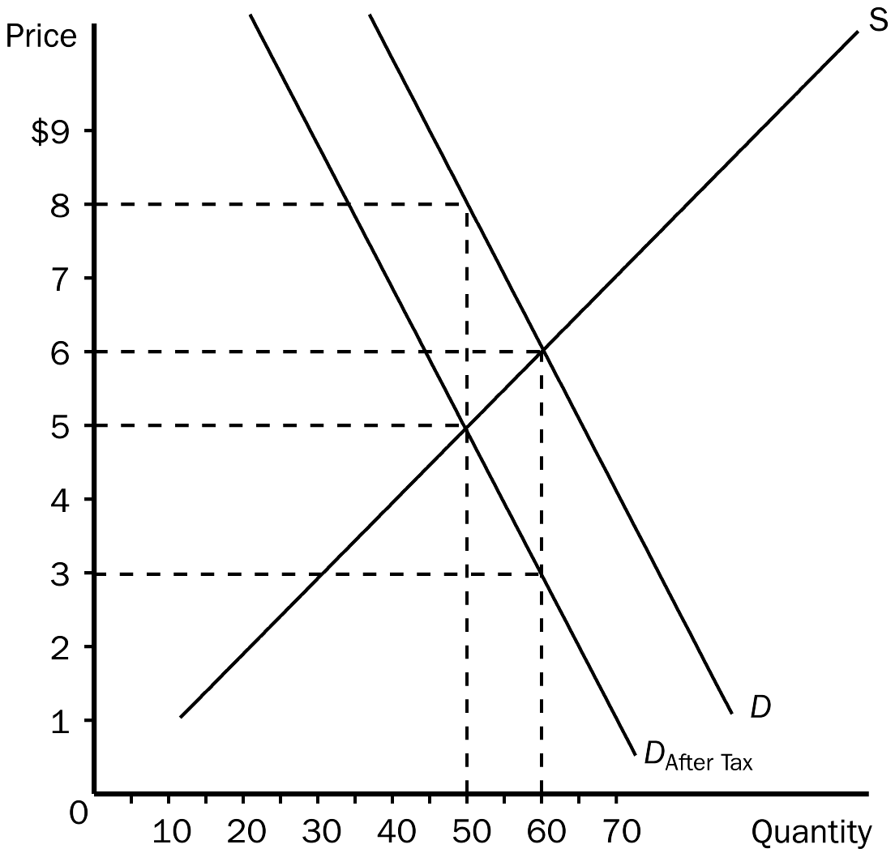
d. $3.00.
ANSWER: b. $6.00.
TYPE: M SECTION: 2 DIFFICULTY: 1
98. According to the graph, the price buyers will pay after the tax is imposed is
a. $8.00.
b. $6.00.
c. $5.00.
d. $3.00.
ANSWER: a. $8.00.
TYPE: M SECTION: 2 DIFFICULTY: 3
99. According to the graph, the price sellers receive after the tax is imposed is
a. $8.00.
b. $6.00.
c. $5.00.
d. $3.00.
ANSWER: c. $5.00.
TYPE: M SECTION: 2 DIFFICULTY: 3
100. According to the graph, the amount of the tax imposed in this market is
a. $1.00.
b. $1.50.
c. $2.50.
d. $3.00.
ANSWER: d. $3.00.
TYPE: M SECTION: 2 DIFFICULTY: 3
101. According to the graph, the amount of the tax that buyers would pay would be
a. $1.00.
b. $1.50.
c. $2.00.
d. $3.00.
ANSWER: c. $2.00.
TYPE: M SECTION: 2 DIFFICULTY: 3
102. According to the graph, the amount of the tax that sellers would pay would be
a. $1.00.
b. $1.50.
c. $2.00.
d. $3.00.
ANSWER: a. $1.00.
TYPE: M SECTION: 2 DIFFICULTY: 3
103. According to the graph, the price buyers will pay after the tax is imposed is
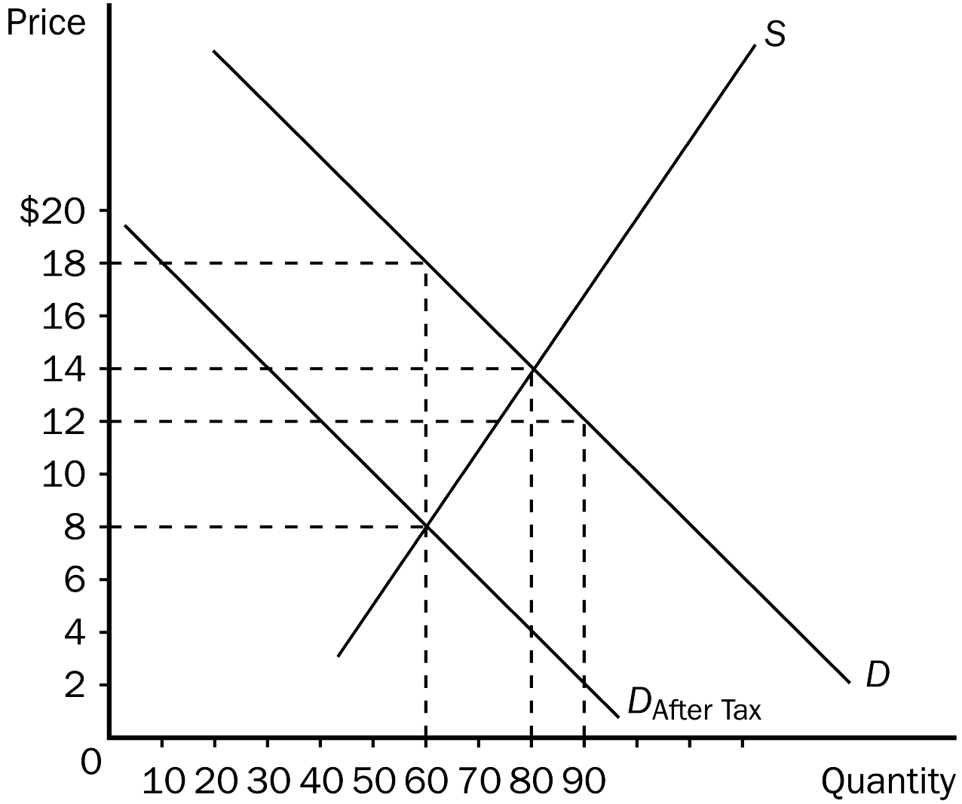
a. $18.00.
b. $14.00.
c. $12.00.
d. $8.00.
ANSWER: a. $18.00.
TYPE: M SECTION: 2 DIFFICULTY: 3
104. According to the graph, the price sellers receive after the tax is imposed is
a. $18.00.
b. $14.00.
c. $12.00.
d. $8.00.
ANSWER: d. $8.00.
TYPE: M SECTION: 2 DIFFICULTY: 3
105. According to the graph, the amount of the tax imposed in this market is
a. $10.00.
b. $6.00.
c. $4.00.
d. $2.00.
ANSWER: a. $10.00.
TYPE: M SECTION: 2 DIFFICULTY: 3
106. According to the graph, the amount of the tax that buyers would pay would be
a. $10.00.
b. $6.00.
c. $4.00.
d. $2.00.
ANSWER: c. $4.00.
TYPE: M SECTION: 2 DIFFICULTY: 3
107. According to the graph, the amount of the tax that sellers would pay would be
a. $10.00.
b. $6.00.
c. $4.00.
d. $2.00.
ANSWER: b. $6.00.
TYPE: M SECTION: 2 DIFFICULTY: 3
108. If buyers are required to pay a $0.10 tax per bag on Hershey’s kisses, the demand for kisses will shift
a. up by $0.10 per bag.
b. up by $0.05 per bag.
c. down by $0.10 per bag.
d. down by $0.05 per bag.
ANSWER: c. down by $0.10 per bag.
TYPE: M SECTION: 2 DIFFICULTY: 2
109. A tax on the buyers of popcorn
a. increases the size of the popcorn market.
b. reduces the size of the popcorn market.
c. has no effect on the size of the popcorn market.
d. may increase, decrease, or have no effect on the size of the popcorn market.
ANSWER: b. reduces the size of the popcorn market.
TYPE: M SECTION: 2 DIFFICULTY: 2
110. A tax on the buyers of coffee will
a. reduce the equilibrium price of coffee, and increase the equilibrium quantity.
b. increase the equilibrium price of coffee, and reduce the equilibrium quantity.
c. increase the equilibrium price of coffee, and increase the equilibrium quantity.
d. reduce the equilibrium price of coffee, and reduce the equilibrium quantity.
ANSWER: b. increase the equilibrium price of coffee, and reduce the equilibrium quantity.
TYPE: M SECTION: 2 DIFFICULTY: 3
111. A tax on the buyers of tea will cause the price the buyer pays
a. and the price the seller receives to rise.
b. and the price the seller receives to fall.
c. to rise and the price the seller receives to fall.
d. to fall and the price the seller receives to rise.
ANSWER: c. to rise and the price the seller receives to fall.
TYPE: M SECTION: 2 DIFFICULTY: 3
112. Which is the most correct statement about the burden of a tax imposed on buyers of sugar?
a. Buyers bear the entire burden of the tax.
b. Sellers bear the entire burden of the tax.
c. Buyers and sellers share the burden of the tax.
d. The government bears the entire burden of the tax.
ANSWER: c. Buyers and sellers share the burden of the tax.
TYPE: M SECTION: 2 DIFFICULTY: 2
113. Suppose a tax is imposed on the buyers of a product. The burden of the tax will fall
a. entirely on the buyers.
b. entirely on the sellers.
c. entirely on the government.
d. on both the buyers and the sellers.
ANSWER: d. on both the buyers and the sellers.
TYPE: M SECTION: 2 DIFFICULTY: 2
114. When a tax is placed on the buyers of milk, the
a. size of the milk market is reduced.
b. price of milk decreases.
c. supply of milk decreases.
d. price of milk increases, and the equilibrium quantity of milk is unchanged.
ANSWER: a. size of the milk market is reduced.
TYPE: M SECTION: 2 DIFFICULTY: 2
115. When a tax is placed on the buyer of a product the result is that buyers pay
a. more and sellers receive less.
b. less and sellers receive less.
c. more and sellers receive more.
d. less and sellers receive more.
ANSWER: a. more and sellers receive less.
TYPE: M SECTION: 2 DIFFICULTY: 2
116. Anytime a tax is placed on the buyers of a product it will
a. reduce the equilibrium price and increase the equilibrium quantity of that product.
b. reduce the equilibrium price and equilibrium quantity of that product.
c. increase the equilibrium price and equilibrium quantity of that product.
d. increase the equilibrium price and reduce the equilibrium quantity of that product.
ANSWER: d. increase the equilibrium price and reduce the equilibrium quantity of that product.
TYPE: M SECTION: 2 DIFFICULTY: 3
117. The initial impact of a tax on the sellers of a product
a. is on the supply of the product.
b. is on the demand for the product.
c. is on both the supply of the product and the demand for the product.
d. Taxes impact both demand and supply.
ANSWER: a. is on the supply of the product.
TYPE: M SECTION: 2 DIFFICULTY: 2
118. If a tax is levied on the seller of a product the demand curve
a. will not change.
b. will shift downward.
c. will shift upward.
d. may shift up or down, depending on the amount of the tax.
ANSWER: a. will not change.
TYPE: M SECTION: 2 DIFFICULTY: 2
119. A tax placed on the seller of a product will
a. raise equilibrium price and lower equilibrium quantity.
b. raise both equilibrium price and quantity.
c. lower equilibrium price and raise equilibrium quantity.
d. lower both equilibrium price and quantity.
ANSWER: a. raise equilibrium price and lower equilibrium quantity.
TYPE: M SECTION: 2 DIFFICULTY: 3
120. A tax placed on the seller of a good
a. raises the price buyers pay and lowers the price sellers receive.
b. lowers the price buyers pay and raises the price sellers receive.
c. raises both the price buyers pay and the price sellers receive.
d. lowers both the price buyers pay and the price sellers receive.
ANSWER: a. raises the price buyers pay and lowers the price sellers receive.
TYPE: M SECTION: 2 DIFFICULTY: 3
121. When a tax is placed on the sellers of a product the
a. size of the market is reduced.
b. price of the product decreases.
c. demand for the product falls.
d. price of the product falls and quantity demand increases.
ANSWER: a. the size of the market is reduced.
TYPE: M SECTION: 2 DIFFICULTY: 2
122. According to the graph shown, the equilibrium price in the market before the tax is imposed is
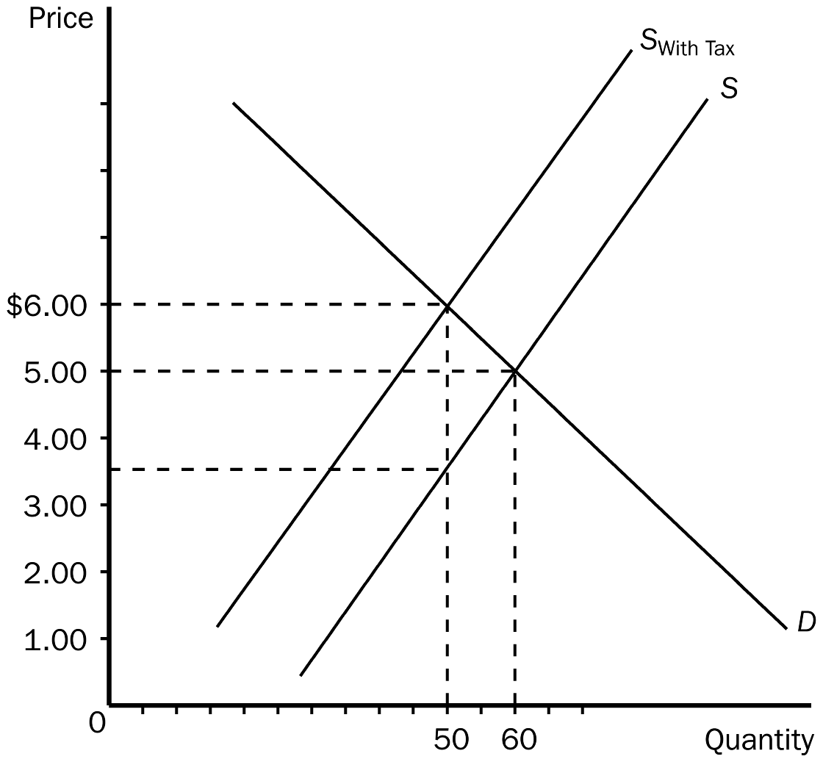
a. $1.00.
b. $3.50.
c. $5.00.
d. $6.00.
ANSWER: c. $5.00.
TYPE: M SECTION: 2 DIFFICULTY: 2
123. According to the graph shown, the equilibrium price in the market after the tax is imposed is
a. $1.00.
b. $3.50.
c. $5.00.
d. $6.00.
ANSWER: d. $6.00.
TYPE: M SECTION: 2 DIFFICULTY: 3
124. According to the graph, the price buyers will pay after the tax is imposed is
a. $1.00.
b. $3.50.
c. $5.00.
d. $6.00.
ANSWER: d. $6.00.
TYPE: M SECTION: 2 DIFFICULTY: 3
125. According to the graph, the price sellers receive after the tax is imposed is
a. $1.00.
b. $3.50.
c. $5.00.
d. $6.00.
ANSWER: b. $3.50.
TYPE: M SECTION: 2 DIFFICULTY: 3
126. According to the graph, the amount of the tax imposed in this market is
a. $1.00.
b. $1.50.
c. $2.50.
d. $3.50.
ANSWER: c. $2.50.
TYPE: M SECTION: 2 DIFFICULTY: 3
127. According to the graph, the amount of the tax that buyers would pay would be
a. $1.00.
b. $1.50.
c. $2.50.
d. $3.00.
ANSWER: a. $1.00.
TYPE: M SECTION: 2 DIFFICULTY: 3
128. According to the graph, the amount of the tax that sellers would pay would be
a. $1.00.
b. $1.50.
c. $2.50.
d. $3.00.
ANSWER: b. $1.50.
TYPE: M SECTION: 2 DIFFICULTY: 3
129. A tax on the sellers of TVs
a. leads sellers to supply a smaller quantity at every price.
b. leads buyers to demand a smaller quantity at every price.
c. leads sellers to supply a larger quantity at every price.
d. causes the supply curve to shift to the right.
ANSWER: a. leads sellers to supply a smaller quantity at every price.
TYPE: M SECTION: 2 DIFFICULTY: 3
130. A tax of $0.10 per bar on the sellers of Snickers will cause the
a. supply curve of Snickers to shift down by $0.10.
b. supply curve of Snickers to shift up by $0.10.
c. supply curve of Snickers to shift down by $0.05.
d. demand curve of Snickers to shift up by $0.10.
ANSWER: b. supply curve of Snickers to shift up by $0.10.
TYPE: M SECTION: 2 DIFFICULTY: 3
131. A tax on the sellers of cell phones will
a. reduce the size of the cell phone market.
b. increase the size of the cell phone market.
c. affect the price of cell phones, but not the size of the market.
d. not have a predictable effect on the size of the cell phone market.
ANSWER: a. reduce the size of the cell phone market.
TYPE: M SECTION: 2 DIFFICULTY: 2
132. A tax on the sellers of tires will
a. reduce the equilibrium price of tires, and increase the equilibrium quantity.
b. reduce the equilibrium price of tires, and reduce the equilibrium quantity.
c. increase the equilibrium price of tires, and increase the equilibrium quantity.
d. increase the equilibrium price of tires, and reduce the equilibrium quantity.
ANSWER: d. increase the equilibrium price of tires, and reduce the equilibrium quantity.
TYPE: M SECTION: 2 DIFFICULTY: 3
133. A tax on the sellers of jewelry will cause the price the buyers pay
a. and the effective price the sellers receive to rise.
b. and the effective price the sellers receive to fall.
c. to rise, and the effective price the sellers receive to fall.
d. to fall, and the price the sellers receive to rise.
ANSWER: c. to rise, and the effective price the sellers receive to fall.
TYPE: M SECTION: 2 DIFFICULTY: 3
134. What is true about the burden of a tax imposed on candles?
a. Buyers bear the entire burden of the tax.
b. Sellers bear the entire burden of the tax.
c. Buyers and sellers share the burden of the tax.
d. The government bears the entire burden of the tax.
ANSWER: c. Buyers and sellers share the burden of the tax.
TYPE: M SECTION: 2 DIFFICULTY: 2
135. A tax placed on the sellers of blueberries
a. increases costs, lowers profit and shifts supply to the left (upward).
b. increases costs, lowers profit and shifts supply to the right (downward).
c. reduces costs, raises profit and shifts supply to the left (upward).
d. increases costs, lowers profit and causes a movement along the supply curve.
ANSWER: a. increases costs, lowers profit and shifts supply to the left (upward).
TYPE: M SECTION: 2 DIFFICULTY: 3
136. A $2.00 tax placed on the sellers of mailboxes will shift the supply curve
a. left (upward) by exactly $2.00.
b. left (upward) by less than $2.00.
c. right (downward) by exactly $2.00.
d. right (downward) by less than $2.00.
ANSWER: a. left (upward) by exactly $2.00.
TYPE: M SECTION: 2 DIFFICULTY: 2
137. When a tax is placed on the sellers of lemonade
a. the sellers pay the entire tax.
b. the buyers pay the entire tax.
c. buyers and sellers share the burden of the tax.
d. the burden of the tax will be always be equally divided between the buyer and the seller.
ANSWER: c. buyers and sellers share the burden of the tax.
TYPE: M SECTION: 2 DIFFICULTY: 2
138. The tax incidence is equivalent
a. if the tax is levied on only the seller.
b. if the tax is levied only on the buyer.
c. if the tax is levied on both the buyer and the seller.
d. regardless of whether the tax is levied on buyers or sellers.
ANSWER: d. regardless of whether the tax is levied on buyers or sellers.
TYPE: M SECTION: 2 DIFFICULTY: 2
139. Revenue from the FICA tax is used to
a. help retire the national debt.
b. cover crop insurance claims.
c. pay the salaries of congressmen.
d. pay for Social Security and Medicare.
ANSWER: d. pay for Social Security and Medicare.
TYPE: M SECTION: 2 DIFFICULTY: 1
140. FICA is an example of
a. a payroll tax.
b. a sales tax.
c. a farm subsidy.
d. fire insurance.
ANSWER: a. a payroll tax.
TYPE: M SECTION: 2 DIFFICULTY: 1
141. A payroll tax is a
a. tax on the wages firms pay their workers.
b. tax each firm must pay to the government to hire workers and operate a business.
c. fixed “per worker” amount each firm pays to the government.
d. tax on all wages above minimum wage.
ANSWER: a. tax on the wages firms pay their workers.
TYPE: M SECTION: 2 DIFFICULTY: 2
142. Congress intended that
a. the entire FICA tax be paid by workers.
b. the entire FICA tax be paid by firms.
c. the entire FICA tax be paid by consumers.
d. half the FICA tax be paid by workers, and half be paid by firms.
ANSWER: d. half the FICA tax be paid by workers, and half be paid by firms.
TYPE: M SECTION: 2 DIFFICULTY: 2
143. Lawmakers enacted the FICA tax to be
a. equally shared between employer and employee.
b. paid mostly by the employer.
c. paid mostly by the employee.
d. entirely paid by the employer.
ANSWER: a. equally shared between employer and employee.
TYPE: M SECTION: 2 DIFFICULTY: 2
144. Although lawmakers legislated a fifty-fifty division in the payment of the FICA tax
a. the same outcome would occur if the entire tax had been levied on only the worker or only on the firm.
b. the employer now is required by law to pay a larger percentage of the tax.
c. the employee now is required by law to pay a larger percentage of the tax.
d. employers are no longer required by law to pay their portion of the tax.
ANSWER: a. the same outcome would occur if the entire tax had been levied on only the worker or only on the firm.
TYPE: M SECTION: 2 DIFFICULTY: 2
145. A key result of a payroll tax is that it
a. becomes a tax on poor people.
b. becomes a tax on corporations.
c. places a wedge between the wage that firms pay and the wage that workers receive.
d. does not affect equilibrium in labor markets.
ANSWER: c. places a wedge between the wage that firms pay and the wage that workers receive.
TYPE: M SECTION: 2 DIFFICULTY: 2
146. When a payroll tax is enacted, the wage received by workers
a. falls and the wage paid by firms rises.
b. falls and the wage paid by firms falls.
c. rises and the wage paid by firms falls.
d. and the wage paid by firms both fall.
ANSWER: a. falls and the wage paid by firms rises.
TYPE: M SECTION: 2 DIFFICULTY: 2
147. Most labor economists believe that the supply of labor is
a. less elastic than demand and therefore firms bear most of the burden of the payroll tax.
b. less elastic than demand and therefore workers bear most of the burden of the payroll tax.
c. more elastic than demand and therefore workers bear most of the burden of the payroll tax.
d. more elastic than demand and therefore firms bear most of the burden of the payroll tax.
ANSWER: b. less elastic than demand and therefore workers bear most of the burden of the payroll tax.
TYPE: M SECTION: 2 DIFFICULTY: 2
148. Although lawmakers designed the burden of the FICA payroll tax to be split fifty-fifty between workers and firms, labor economists believe that
a. the labor market is too distorted by the tax and should be eliminated.
b. firms bear most of the burden of the tax.
c. lawmakers may have actually achieved their goal, since statistics show that the tax burden is currently equally divided.
d. workers bear most of the burden of the tax.
ANSWER: d. workers bear most of the burden of the tax.
TYPE: M SECTION: 2 DIFFICULTY: 2
149. In the end, tax incidence
a. depends on the legislated burden.
b. is entirely random.
c. depends on the forces of supply and demand.
d. falls entirely on buyers or entirely on sellers.
ANSWER: c. depends on the forces of supply and demand.
TYPE: M SECTION: 2 DIFFICULTY: 2

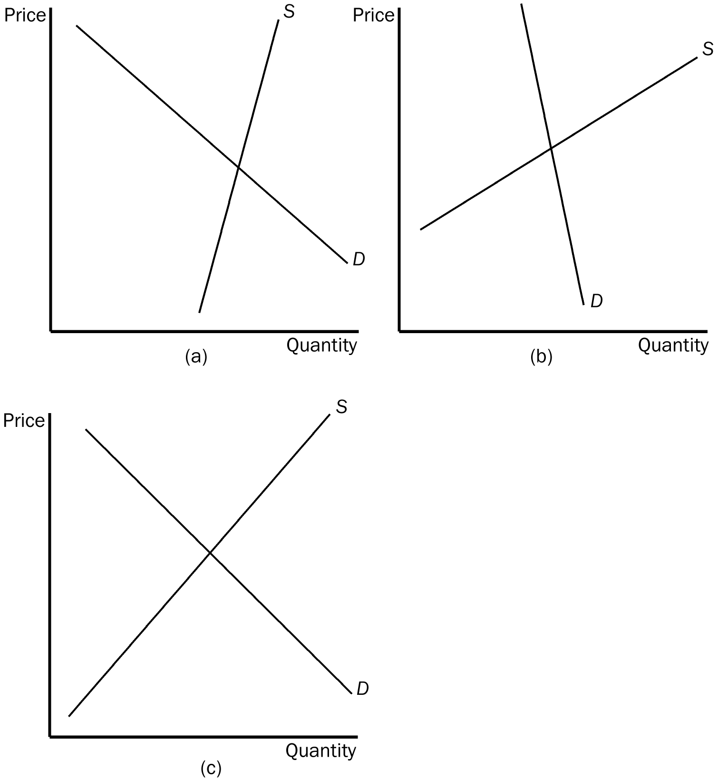

150. According to the graphs given, in which market will the majority of a tax be paid by the buyer?
a. market (a)
b. market (b)
c. market (c)
d. All of the above are correct.
ANSWER: b. market (b)
TYPE: M SECTION: 2 DIFFICULTY: 2
151. According to the graphs given, in which market will the majority of a tax be paid by the seller?
a. market (a)
b. market (b)
c. market (c)
d. All of the above are correct.
ANSWER: a. market (a)
TYPE: M SECTION: 2 DIFFICULTY: 2
152. According to the graphs given, in which market will the tax be most equally divided between the buyer and the seller?
a. market (a)
b. market (b)
c. market (c)
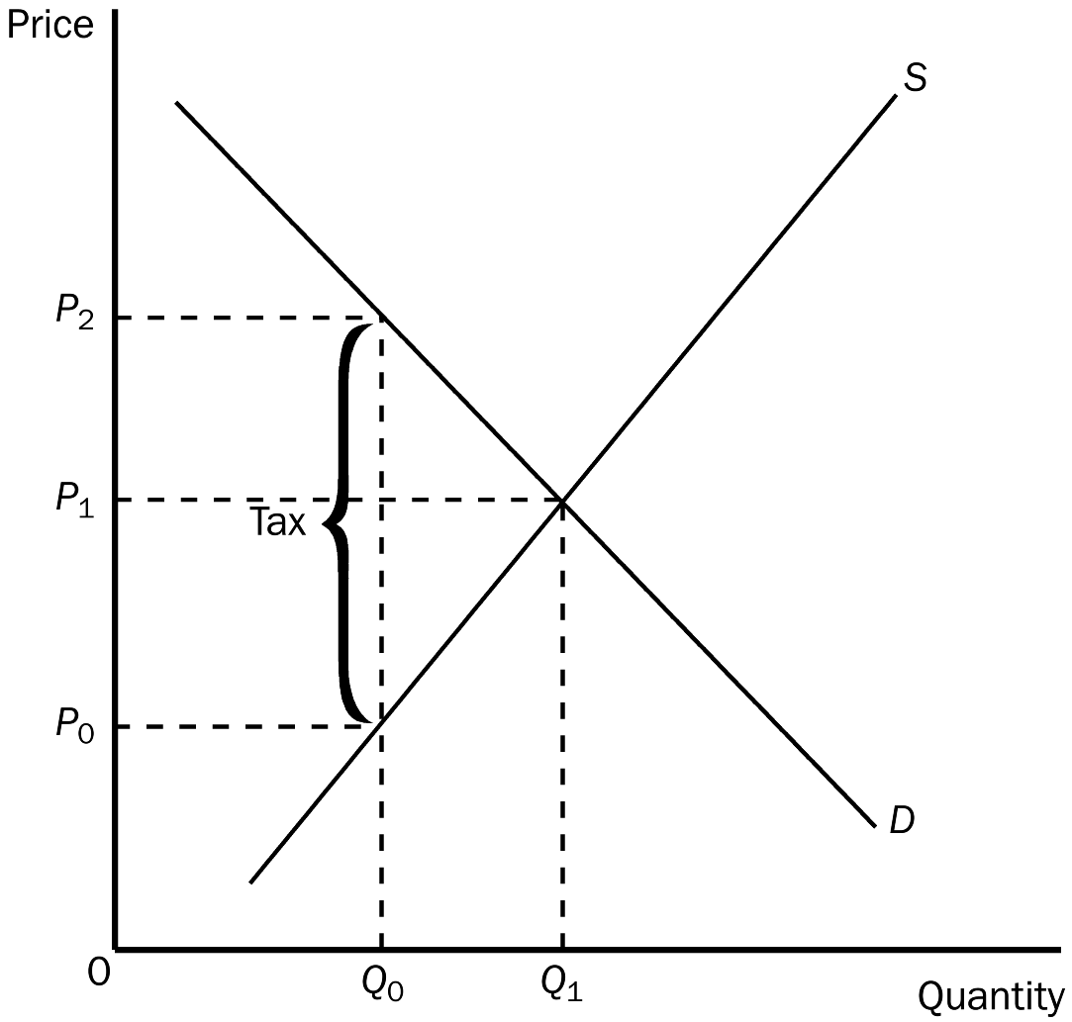
d. All of the above are correct.
ANSWER: c. market (c)
TYPE: M SECTION: 2 DIFFICULTY: 2
153. In the graph shown, the equilibrium price before the tax is
a. P₀.
b. P₁.
c. P₂.
d. None of the above are correct.
ANSWER: b. P₁.
TYPE: M SECTION: 2 DIFFICULTY: 2
154. In the graph shown, the price that will be paid after the tax is
a. P₀.
b. P₁.
c. P₂.
d. impossible to determine.
ANSWER: c. P₂.
TYPE: M SECTION: 2 DIFFICULTY: 2
155. In the graph shown, the price sellers receive after the tax is
a. P₀.
b. P₁.
c. P₂.
d. impossible to determine.
ANSWER: a. P₀.
TYPE: M SECTION: 2 DIFFICULTY: 2
156. In the graph shown, the per unit burden of the tax on buyers is
a. P₂ minus P₀.
b. P₂ minus P₁.
c. P₁ minus P₀.
d. Q₁ minus Q₀.
ANSWER: b. P₂ minus P₁.
TYPE: M SECTION: 2 DIFFICULTY: 3
157. In the graph shown, the per unit burden of the tax on the sellers is
a. P₂ minus P₀.
b. P₂ minus P₁.
c. P₁ minus P₀.
d. Q₁ minus Q₀.
ANSWER: c. P₁ minus P₀.
TYPE: M SECTION: 2 DIFFICULTY: 3
158. In the graph shown, the amount of the tax imposed is
a. P₂ minus P₀.
b. P₂ minus P₁.
c. P₁ minus P₀.
d. Q₁ minus Q₀.
ANSWER: a. P₂ minus P₀.
TYPE: M SECTION: 2 DIFFICULTY: 3
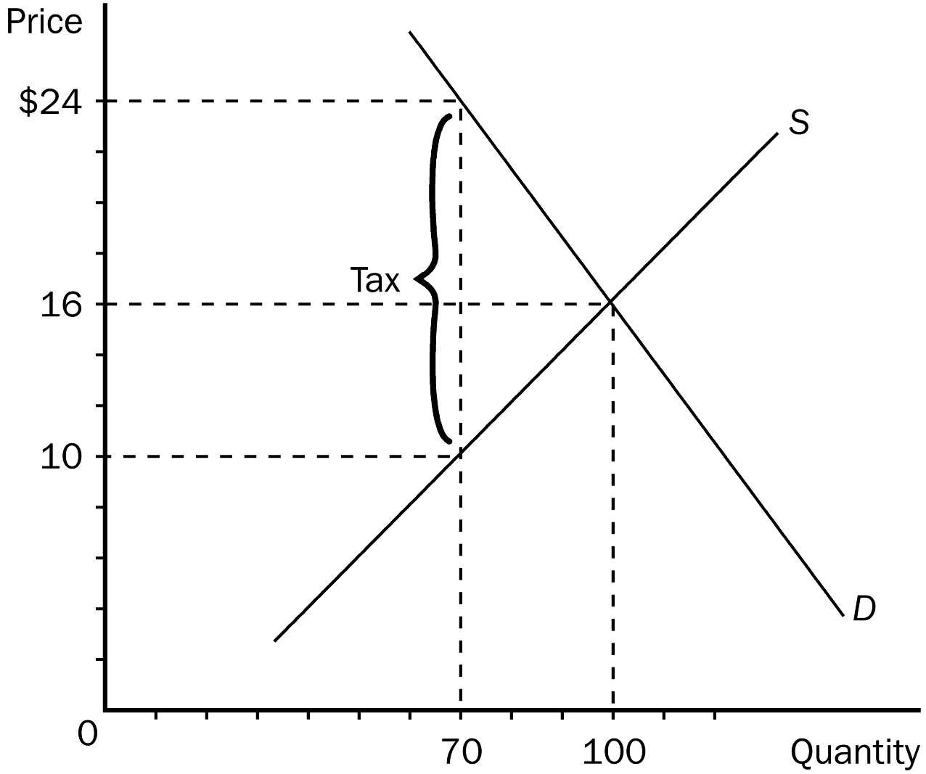
159. In the graph shown, the equilibrium price before the tax is
a. $24.
b. $16.
c. $10.
d. $8.
ANSWER: b. $16.
TYPE: M SECTION: 2 DIFFICULTY: 1
160. In the graph shown, the price that will be paid after the tax is
a. $24.
b. $16.
c. $10.
d. $8.
ANSWER: a. $24.
TYPE: M SECTION: 2 DIFFICULTY: 3
161. In the graph shown, the price sellers receive after the tax is
a. $24.
b. $14.
c. $10.
d. $8.
ANSWER: c. $10.
TYPE: M SECTION: 2 DIFFICULTY: 2
162. In the graph shown, the per unit burden of the tax on buyers is
a. $16.
b. $14.
c. $8.
d. $6.
ANSWER: c. $8.
TYPE: M SECTION: 2 DIFFICULTY: 3
163. In the graph shown, the per unit burden of the tax on the sellers is
a. $16.
b. $14.
c. $8.
d. $6.
ANSWER: d. $6
TYPE: M SECTION: 2 DIFFICULTY: 3
164. In the graph shown, the amount of the tax imposed is
a. $16.
b. $14.
c. $8.
d. $6.
ANSWER: b. $14
TYPE: M SECTION: 2 DIFFICULTY: 3
165. If a tax is imposed on a market with inelastic demand and elastic supply,
a. buyers will bear most of the burden of the tax.
b. sellers will bear most of the burden of the tax.
c. the burden of the tax will be shared equally between buyers and sellers.
d. it is impossible to determine how the burden of the tax will be shared.
ANSWER: a. buyers will bear most of the burden of the tax.
TYPE: M SECTION: 2 DIFFICULTY: 3
166. Buyers of a product will pay the majority of a tax placed on a product when
a. supply is more elastic than demand.
b. the demand in more elastic than supply.
c. the tax is placed on the seller of the product.
d. the tax is placed on the buyer of the product.
ANSWER: a. supply is more elastic than demand.
TYPE: M SECTION: 2 DIFFICULTY: 2
167. If a tax is imposed on a market with elastic demand and inelastic supply,
a. buyers will bear most of the burden of the tax.
b. sellers will bear most of the burden of the tax.
c. the burden of the tax will be shared equally between buyers and sellers.
d. it is impossible to determine how the burden of the tax will be shared.
ANSWER: b. sellers will bear most of the burden of the tax.
TYPE: M SECTION: 2 DIFFICULTY: 3
168. When a tax is placed on the sellers of a product it will shift the
a. supply curve down.
b. supply curve up.
c. demand curve up.
d. demand curve down.
ANSWER: b. supply curve up.
TYPE: M SECTION: 2 DIFFICULTY: 2
169. Which of the following is the most correct statement about tax burdens?
a. A tax burden falls most heavily on the side of the market that is more elastic.
b. A tax burden falls most heavily on the side of the market that is more inelastic.
c. A tax burden falls most heavily on the side of the market that is closer to unit elastic.
d. A tax burden is distributed independently of relative elasticities of supply and demand.
ANSWER: b. A tax burden falls most heavily on the side of the market that is more inelastic.
TYPE: M SECTION: 2 DIFFICULTY: 2
170. In general, a tax burden falls more heavily on the side of the market that is
a. perfectly elastic.
b. more elastic.
c. unit elastic.
d. less elastic.
ANSWER: d. less elastic.
TYPE: M SECTION: 2 DIFFICULTY: 2
171. The burden of a tax placed on a product
a. depends on the supply and demand of that product.
b. depends on how lawmakers decide the burden should be placed.
c. usually falls more heavily on the buyer.
d. usually falls more heavily on the seller.
ANSWER: a. depends on the supply and demand of that product.
TYPE: M SECTION: 2 DIFFICULTY: 2
172. Suppose that a tax is placed on DVDs. If the seller ends up paying the majority of the tax we know that the
a. demand curve is more inelastic than the supply curve.
b. supply curve is more inelastic than the demand curve.
c. government has placed the tax on the seller.
d. government has placed the tax on the buyer.
ANSWER: b. supply curve is more inelastic than the demand curve.
TYPE: M SECTION: 2 DIFFICULTY: 2
173. Suppose that a tax is placed on books. If the buyer pays the majority of the tax we know that the
a. supply curve is more inelastic than the demand curve.
b. demand curve is more inelastic than the supply curve.
c. government has placed the tax on the seller.
d. government has placed the tax on the buyer.
ANSWER: b. demand curve is more inelastic than the supply curve.
TYPE: M SECTION: 2 DIFFICULTY: 2
174. In 1990, Congress passed a new luxury tax on items such as yachts, private airplanes, furs, jewelry, and expensive cars. The goal of the tax was to
a. raise revenue from the wealthy.
b. prevent rich people from buying luxuries.
c. force producers of luxury goods to reduce employment.
d. limit exports of luxury goods to other countries.
ANSWER: a. raise revenue from the wealthy.
TYPE: M SECTION: 2 DIFFICULTY: 2
175. Which of the following was NOT a result of the luxury tax imposed by Congress in 1990?
a. The burden of the tax fell on suppliers.
b. The burden of the tax fell more on the middle class than on the rich.
c. The demand for many luxury goods fell.
d. Government revenue from the tax increased substantially.
ANSWER: d. Government revenue from the tax increased substantially.
TYPE: M SECTION: 2 DIFFICULTY: 2
176. The burden of a luxury tax falls
a. more on the rich than on the middle class.
b. more on the poor than on the middle class.
c. more on the middle class than on the rich.
d. equally on the rich, the middle class, and the poor.
ANSWER: c. more on the middle class than on the rich.
TYPE: M SECTION: 2 DIFFICULTY: 2
177. When analyzing the economic effects of government policies,
a. supply and demand are useful tools of analysis.
b. one finds that the effects are always those stated in the legislation.
c. supply and demand are not useful, since they apply only to unregulated markets.
d. one usually finds them to be the random outcome of economic shocks.
ANSWER: a. supply and demand are useful tools of analysis.
TYPE: M SECTION: 2 DIFFICULTY: 2
178. Which of the following is the LEAST likely to result from the imposition of a price ceiling in the market for rental cars?
a. free gasoline given to people as an incentive to a rent car
b. poor engine maintenance in rental cars
c. an accumulation of dirt in the interior of rental cars
d. slow replacement of old rental cars with new ones
ANSWER: a. free gasoline given to people as an incentive to a rent car
TYPE: M SECTION: 1 DIFFICULTY: 2
179. Which of the following is the MOST likely to result from the imposition of a price floor in the market for rental cars?
a. free gasoline given to people as an incentive to a rent car
b. poor engine maintenance in rental cars
c. an accumulation of dirt on the interior of rental cars
d. slow replacement of old rental cars with new ones
ANSWER: a. free gasoline given to people as an incentive to a rent car
TYPE: M SECTION: 1 DIFFICULTY: 2
180. You have responsibility for economic policy in the country of Freedonia. Recently the neighboring country of Sylvania has cut off all exports of oranges to Freedonia. Harpo, who is one of your advisors, suggests that you should impose a binding price ceiling in order to avoid a shortage of oranges. Chico, another one of your advisors, argues that without a binding price floor, a shortage will certainly develop. Zeppo, a third advisor, says that the best way to avoid a shortage of oranges is to take no action at all. Which of your three advisors is most likely to have studied economics?
a. Harpo
b. Chico
c. Zeppo
d. none of them
ANSWER: c. Zeppo
TYPE: M SECTION: 1 DIFFICULTY: 2
181. One economist has argued that rent control is “the best way to destroy a city, other than bombing.” Why would an economist say this?
a. He fears that low rents will cause low-income people to move into the city, reducing the quality of life for other people.
b. He fears that rent control will benefit landlords at the expense of tenants, increasing inequality in the city.
c. He fears that rent controls will cause a construction boom, which will make the city crowded and more polluted.
d. He fears that rent control will eliminate the incentive to maintain buildings, leading to a deterioration of the city.
ANSWER: d. He fears that rent control will eliminate the incentive to maintain buildings, leading to a deterioration of the city.
TYPE: M SECTION: 1 DIFFICULTY: 2
182. Which of the following is the most likely explanation for the imposition of a price floor in the market for corn?
a. Policy makers have studied the effects of the price floor carefully and recognize that the price floor is advantageous for society as a whole.
b. Buyers and sellers of corn have agreed that the price floor is good for both of them and have therefore pressured policy makers into enacting the price floor.
c. Buyers of corn, recognizing that the price floor is good for them, have pressured policy makers into enacting the price floor.
d. Sellers of corn, recognizing that the price floor is good for them, have pressured policy makers into enacting the price floor.
ANSWER: d. Sellers of corn, recognizing that the price floor is good for them, have pressured policy makers into enacting the price floor.
TYPE: M SECTION: 1 DIFFICULTY: 2
183. The long-run effects of rent controls are a good illustration of the principle that
a. society faces a short-run tradeoff between unemployment and inflation.
b. the cost of something is what you give up to get it.
c. people respond to incentives.
d. government can sometimes improve on market outcomes.
ANSWER: c. people respond to incentives.
TYPE: M SECTION: 1 DIFFICULTY: 2
184. Which of the following statements is true?
a. A tax levied on buyers will never even partially be paid by sellers.
b. Who actually pays a tax depends on the price elasticity of supply and demand.
c. Government can decide who actually pays a tax.
d. A tax levied on sellers will always be passed on completely to buyers.
ANSWER: b. Who actually pays a tax depends on the price elasticity of supply and demand.
TYPE: M SECTION: 2 DIFFICULTY: 2
185. Suppose that the demand for picture frames is price elastic and the supply of picture frames is price inelastic. A tax of $1 per frame levied on buyers of picture frames will increase the equilibrium price paid by buyers of picture frames by
a. $1.
b. more than $0.50 but less than $1.00.
c. less than $0.50.
d. It is impossible to say without more information.
ANSWER: c. less than $0.50.
TYPE: M SECTION: 2 DIFFICULTY: 2
186. Suppose that the demand for picture frames is price inelastic and the supply of picture frames is price elastic. A tax of $1 per frame levied on buyers of picture frames will increase the equilibrium price paid by buyers of picture frames by
a. $1.
b. more than $0.50 but less than $1.00.
c. less than $0.50.
d. It is impossible to say without more information.
ANSWER: b. more than $0.50 but less than $1.00.
TYPE: M SECTION: 2 DIFFICULTY: 2
187. The demand for salt is price inelastic and the supply of salt is price elastic. The demand for caviar is price elastic and the supply of caviar is price inelastic. Suppose that a tax of $1 per pound is levied on the sellers of salt and a tax of $1 per pound is levied on the buyers of caviar. We would expect that most of these taxes will be paid by the
a. sellers of salt and the buyers of caviar.
b. sellers of salt and the sellers of caviar.
c. buyers of salt and the sellers of caviar.
d. buyers of salt and the buyers of caviar.
ANSWER: c. buyers of salt and the sellers of caviar.
TYPE: M SECTION: 2 DIFFICULTY: 2
188. Suppose that the demand for macaroni is price inelastic and the supply of macaroni is price elastic, and that the demand for cigarettes is price inelastic and the supply of cigarettes is price elastic. If a tax were levied on the sellers of both of these commodities, we would expect that the
a. sellers of both goods would pay most of the tax.
b. buyers of both goods would pay most of the tax.
c. sellers of cigarettes and the buyers of macaroni would pay most of the tax.
d. We could not be sure who would actually pay most of the tax.
ANSWER: b. buyers of both goods would pay most of the tax.
TYPE: M SECTION: 2 DIFFICULTY: 2
TRUE/FALSE
1. Economic policies often have effects that their architects did not intend or anticipate.
ANSWER: T TYPE: T
2. Policymakers use taxes both to raise revenue for public purposes and to influence market outcomes.
ANSWER: T TYPE: T
3. A price ceiling is a legal minimum on the price of a good or service.
ANSWER: F TYPE: T
4. If a price ceiling of $2 per gallon is imposed on gasoline, but the market equilibrium price is $1.50, the price ceiling is a binding constraint on the market.
ANSWER: F TYPE: T SECTION: 1
5. If a price ceiling is not binding, it will have no effect on the market.
ANSWER: T TYPE: T SECTION: 1
6. If a price ceiling is below equilibrium price, the quantity demanded will exceed the quantity supplied.
ANSWER: T TYPE: T SECTION: 1
7. Binding price ceilings benefit consumers because they allow consumers to buy all the goods they demand at a lower price.
ANSWER: F TYPE: T SECTION: 1
8. When free markets ration goods with prices it is both efficient and impersonal.
ANSWER: T TYPE: T SECTION: 1
9. Long gas lines in the United States after OPEC raised the price of crude oil in world markets were caused by the higher prices of oil and gas.
ANSWER: F TYPE: T SECTION: 1
10. The housing shortages caused by rent controls are larger in the long run than in the short run because both the supply of housing and the demand for housing are more elastic in the long run.
ANSWER: T TYPE: T SECTION: 1
11. Rent control may lead to lower rents for those who find housing, but the quality of the housing may also be lower.
ANSWER: T TYPE: T SECTION: 1
12. If the equilibrium wage rate is $4 per hour, and the minimum wage is $5.15 per hour, a shortage of labor will exist.
ANSWER: F TYPE: T SECTION: 1
13. A binding minimum wage in a competitive labor market creates unemployment.
ANSWER: T TYPE: T SECTION: 1
14. Most economists are in favor of price controls as a way of allocating resources in the economy.
ANSWER: F TYPE: T SECTION: 1
15. Rent subsidies and wage subsidies are better than price controls at helping the poor because they have no costs associated with them.
ANSWER: F TYPE: T SECTION: 1
16. Economists use the term tax incidence to refer to who is legally responsible for paying the tax.
ANSWER: F TYPE: T SECTION: 1
17. If buyers of a product are required to pay a tax, the demand curve for the product will shift downward by exactly the size of the tax.
ANSWER: T TYPE: T SECTION: 1
18. A government imposed tax on a market shrinks the size of the market.
ANSWER: T TYPE: T SECTION: 1
19. A tax on golf clubs will cause the equilibrium market price of golf clubs to increase, and the equilibrium quantity sold to decrease.
ANSWER: T TYPE: T SECTION: 1
20. If a tax is imposed on the buyer of a product, the tax incidence will fall entirely on the buyer, causing the buyer to pay more.
ANSWER: F TYPE: T SECTION: 1
21. A tax on sellers shifts the supply curve upward by exactly the size of the tax.
ANSWER: T TYPE: T SECTION: 1
22. The incidence of a tax depends on whether the tax is levied on buyers or sellers.
ANSWER: F TYPE: T SECTION: 1
23. Since half of the FICA tax is paid by firms, and the other half is paid by workers, the burden of the tax must fall equally on firms and workers.
ANSWER: F TYPE: T SECTION: 1
24. Lawmakers can decide whether the buyer or the seller must send a tax to the government, but they cannot legislate the true burden of a tax.
ANSWER: T TYPE: T SECTION: 1
25. Who pays the majority of a tax levied on a product depends on whether the tax is placed on the buyer or the seller.
ANSWER: F TYPE: T SECTION: 1
26. In general, a tax burden falls more heavily on the side of the market that is more inelastic.
ANSWER: T TYPE: T SECTION: 1
27. Most of the burden of a luxury tax falls on the middle class workers who supply luxury goods rather than on the rich who buy them.
ANSWER: T TYPE: T SECTION: 1
SHORT ANSWER
1. Using a supply-demand diagram, show a labor market with a binding minimum wage. Now, use the diagram to show those who are helped by the minimum wage, and those who are hurt by the minimum wage.
ANSWER:
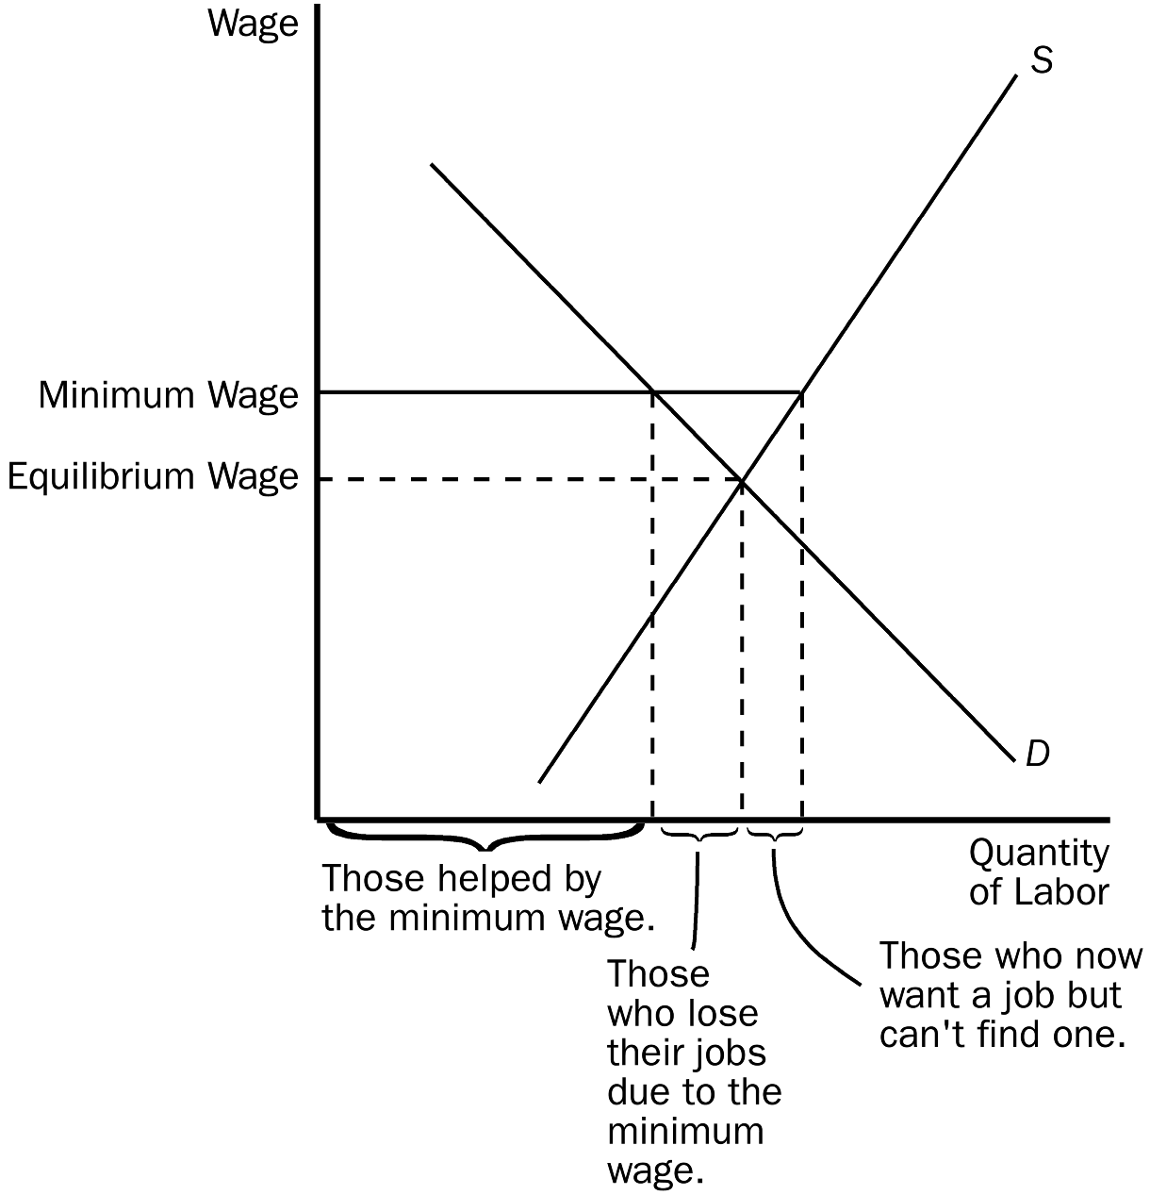
Those helped by the minimum wage are the workers who are still employed, but now receive the higher wage. In the diagram, those would be measured by the quantity of labor demanded at the minimum wage. Those who are hurt by the minimum wage are those who are now unemployed. These workers are measured as the difference between the quantity of labor supplied and the quantity demanded at the minimum wage. The perceptive student might note that the unemployed group can be divided into those who lose their jobs as a result of the minimum wage (the competitive equilibrium quantity of labor minus the quantity demanded at the minimum wage), and those who enter the market as a result of the higher wage, but cannot find employment (quantity of labor supplied at the minimum wage minus the competitive equilibrium quantity). The buyers of the labor (employers) are also worse off because they have to pay a higher wage for labor, hence, hire a smaller quantity.
TYPE: S KEY1: G SECTION: 1 OBJECTIVE: 2 RANDOM: Y
2.
a. Using the graph shown, analyze the effect a $300 price ceiling would have on the market for ten-speed bicycles. Would this be a binding price ceiling?
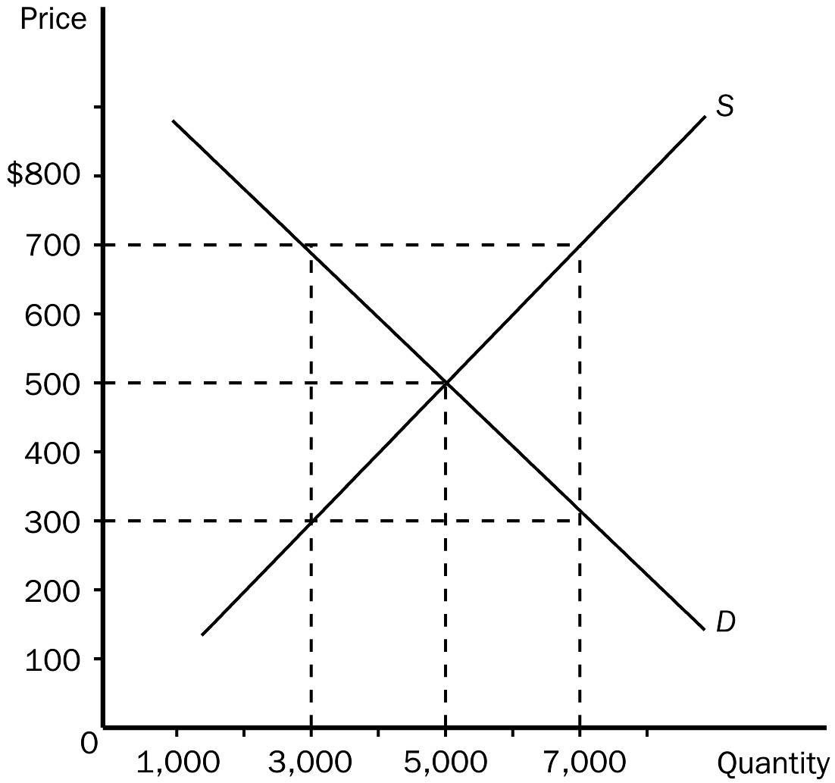
b. Using the graph shown, analyze the effect a $700 price floor would have on this market. Would this be a binding price floor?
c. Why would policymakers choose to impose a price ceiling or price floor?
ANSWER:
a. For this example, a $300 price ceiling would cause a shortage of 4,000 bicycles. A price ceiling is binding if it is set at any price below equilibrium price. Since the equilibrium price in the market is $500, this would be a binding price ceiling.
b. For this example, a $700 price floor would cause a surplus of 4,000 bicycles. A price floor is binding if it is set at any price above equilibrium price. Since the equilibrium price in the market is $500, this would be a binding price floor.
c. More than one reason may exist for policymakers to impose a price ceiling or price floor in a market. Often this is done in an attempt to increase equity.
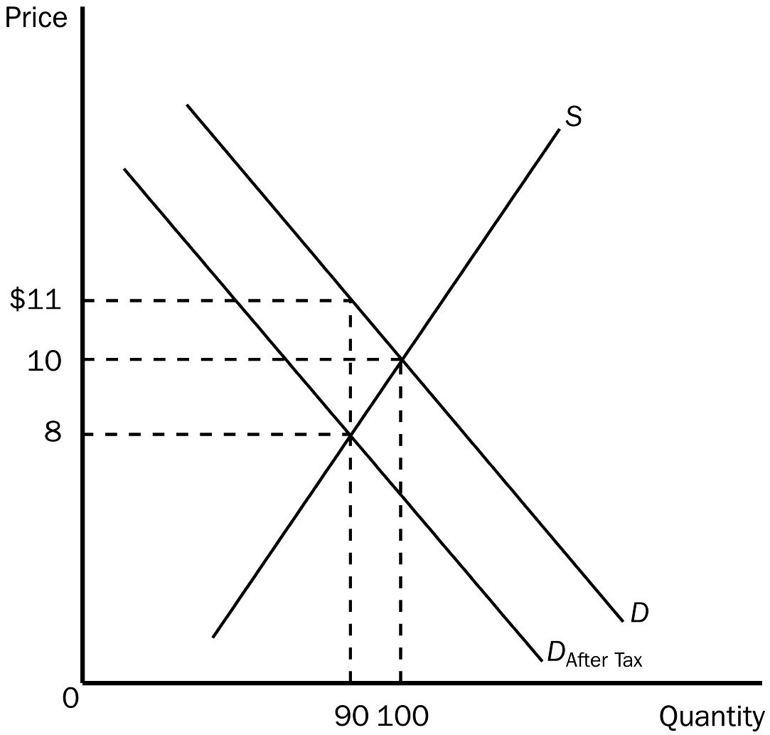
TYPE: S SECTION: 1
3. Using the graph shown, answer the following questions.
a. What was the equilibrium price in this market before the tax?
b. What is the amount of the tax?
c. How much of the tax will the buyers pay?
d. How much of the tax will the sellers pay?
e. How much will the buyer pay for the product after the tax is imposed?
f. How much will the seller receive after the tax is imposed?
g. As a result of the tax, what has happened to the level of market activity?
ANSWER: a. $10
b. $3
c. $1
d. $2
e. $11
f. $8
g. As a result of the tax, the level of market activity has fallen, from 100 units being bought and sold to only 90 units being bought and sold.
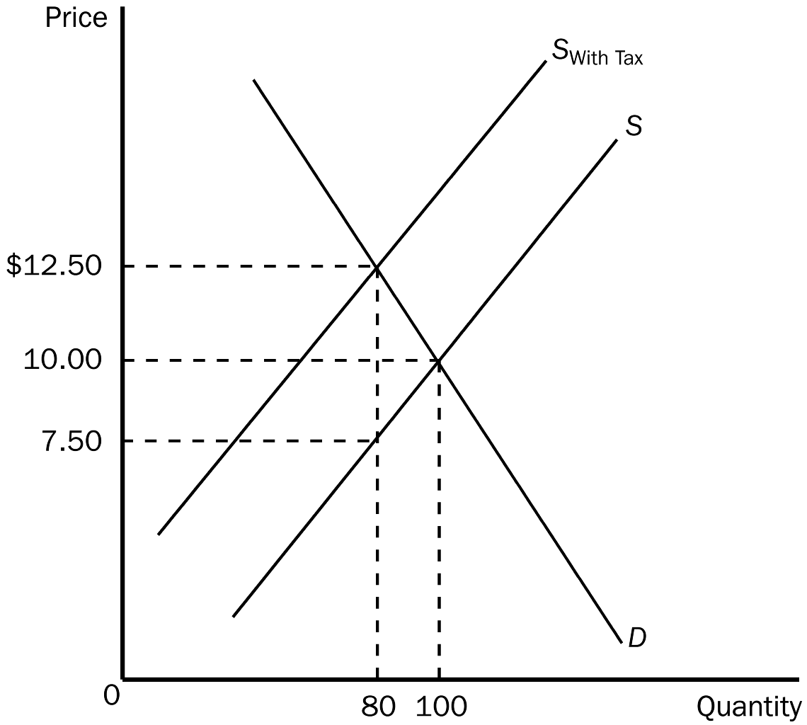
TYPE: S SECTION: 2
4. Using the graph shown, answer the following questions.
a. What was the equilibrium price in this market before the tax?
b. What is the amount of the tax?
c. How much of the tax will the buyers pay?
d. How much of the tax will the sellers pay?
E. How much will the buyer pay for the product after the tax is imposed?
F. How much will the seller receive after the tax is imposed?
G. As a result of the tax, what has happened to the level of market activity?
ANSWER:
a. $10.00
b. $5.00
c. $2.50
d. $2.50
e. $12.50
f. $7.50
g. As a result of the tax, the level of market activity has fallen, from 100 units being bought and sold to only 80 units being bought and sold.
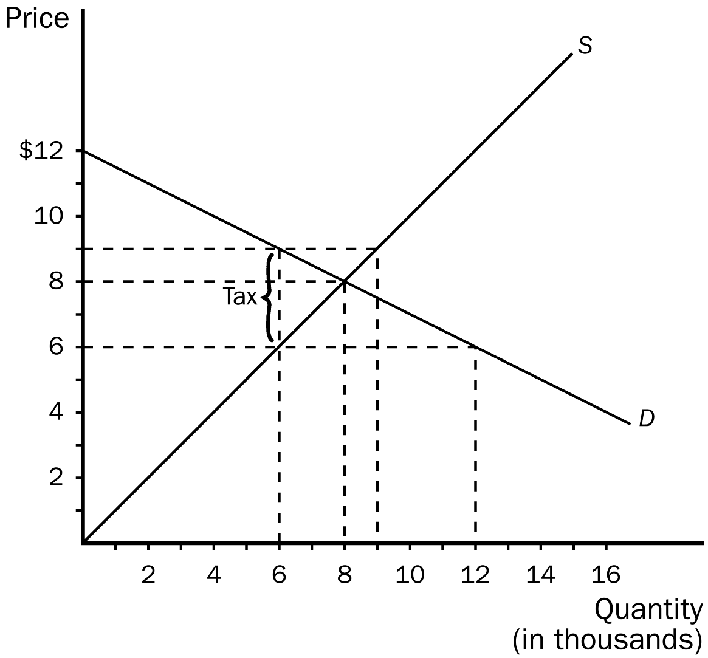
TYPE: S SECTION: 2
5. Using the graph shown, answer the following questions.
a. What was the equilibrium price and quantity in this market before the tax?
b. What is the amount of the tax?
c. How much of the tax will the buyers pay?
d. How much of the tax will the sellers pay?
e. How much will the buyer pay for the product after the tax is imposed?
f. How much will the seller receive after the tax is imposed?
g. As a result of the tax, what has happened to the level of market activity?
ANSWER:
a. Equilibrium price is $8 and equilibrium is 8,000 units.
b. The tax is $3.00.
c. Buyers will pay $1.00.
d. Sellers will pay $2.00.
e. $9.00
f. $6.00
g. Instead of 8,000 units being bought and sold, only 6,000 will be bought and sold.
TYPE: S SECTION: 2
6. How does elasticity affect the burden of a tax? Justify your answer using supply and demand diagrams.
ANSWER:
